# INTRODUCTION

A Database is a collection of data stored in a format that can easily be accessed. In order to manage our databases, we use a software called Database Management System aka DBMS.

We connect to a DBMS and give it instructions to query or modify data. The DBMS will execute our instructions and give the results back.

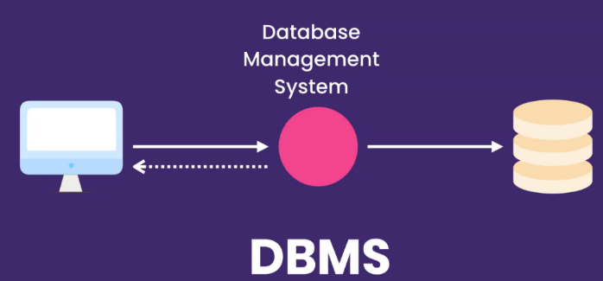

We have many DBMS software’s in the market and they are mostly classified into two categories:

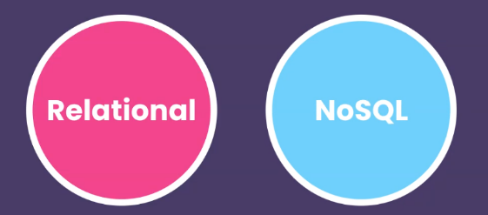

In relational databases we store data in tables that are linked to each other via relationships.

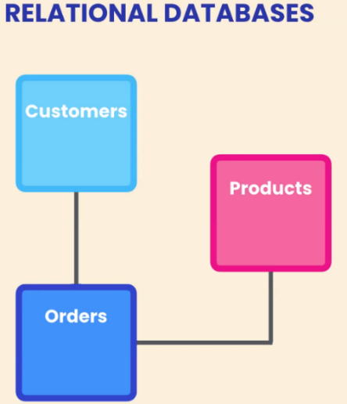

Some of the most popular RDBMS are

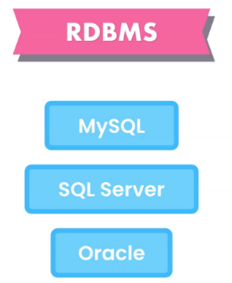

We interact with RDBMS using SQL / SQUEL. NoSQL DBMS does not understand SQL.

# GETTING STARTED WITH SQL SERVER

Microsoft SQL Server is a relational database management system developed by Microsoft. As a database server, it is a software product with the primary function of storing and retrieving data as requested by other software applications.

A server is a physical or virtual machine hosting RDBMS software. When we install Microsoft SQL Server on a machine, it will ask for instance name and reference memory will be allocated for the instance. Using this server instance, we can create databases on the named instance and maintain the databases available on that particular instance.

We can create multiple databases on the server instance and the sys admin will have access to all the databases created on the instance.

As of July 2019, the following versions are supported by Microsoft:

* SQL Server 2012
* SQL Server 2014
* SQL Server 2016
* SQL Server 2017

Microsoft SQL Server is a platform dependent product. SQL Server 2016 and earlier versions can only be installed on windows OS. With SQL Server 2017, they have added support for Linux as well. From SQL Server 2016 onward, the product is supported on x64 processors only.

SQL Server consists of two main components:

* Database Engine
* SQLOS

## DATABASE ENGINE

The core component of the SQL Server is the Database Engine. The Database Engine consists of a relational engine that processes queries and a storage engine that manages database files, pages, pages, index, etc. The database objects such as stored procedures, views, and triggers are also created and executed by the Database Engine.

### RELATIONAL ENGINE

The Relational Engine contains the components that determine the best way to execute a query. The relational engine is also known as the query processor.

The relational engine requests data from the storage engine based on the input query and processed the results.

Some tasks of the relational engine include querying processing, memory management, thread and task management, buffer management, and distributed query processing.

### STORAGE ENGINE

The storage engine is in charge of storage and retrieval of data from the storage systems such as disks and SAN.

## SQLOS

Under the relational engine and storage engine is the SQL Server Operating System or SQLOS.

SQLOS provides many operating system services such as memory and I/O management. Other services include exception handling and synchronization services.

## SQL SERVER INSTANCES

SQL Server allows you to run multiple services at a go, with each service having separate logins, ports, databases, etc. These are divided into two:

* Primary instances
* Named instances.

There are two ways through which we may access the primary instance. First, we can use the server name. Secondly, we can use its IP address. Named instances are accessed by appending a backslash and instance name.

For example, to connect to an instance named xyx on the local server, you should use 127.0.0.1\xyz. From SQL Server 2005 and above, you are allowed to run up to 50 instances simultaneously on a server.

Note that even though you can have multiple instances on the same server, only one of them must be the default instance while the rest must be named instances. One can run all the instances concurrently, and each instance runs independent of the other instances.

SQL server browser listens on the port 1434 and as the request comes in for the names instance over TCP-IP, the browser then directs them to appropriate instances or specific port which is assigned dynamically.

The following are the advantages of SQL Server instances:

1. **For installation of different versions on one machine:** You can have different versions of SQL Server on a single machine. Each installation works independently from the other installations.
2. **For maintenance of development, production and test environments separately:** This is the main benefit of having many SQL Server instances on a single machine. You can use different instances for development, production and test purposes.
3. **For separating security privileges:** When different services are running on different SQL Server instances, you can focus on securing the instance running the most sensitive service.
4. **For maintaining a standby server:** A SQL Server instance can fail, leading to an outage of services. This explains the importance of having a standby server to be brought in if the current server fails. This can easily be achieved using SQL Server instances.

## KEY COMPONENTS AND SERVICES OF SQL SERVER

**SQL SERVER AGENT:** It performs the role of Task Scheduler. It can be triggered by any event or as per demand. Executable name is sqlagent.exe.

**SQL SERVER BROWSER:** This listens to the incoming request and connects to the desired SQL server instance. Executable name is sqlbrowser.exe.

**SQL SERVER FULL-TEXT SEARCH:** This lets user running full-text queries against Character data in SQL Tables. Executable name is fdlauncher.exe.

**SQL SERVER VSS WRITER:** This allows backup and restoration of data files when the SQL server is not running. Executable name is sqlwriter.exe.

**SQL SERVER ANALYSIS SERVICES (SSAS):** Provide Data analysis, Data mining and Machine Learning capabilities. SQL server is integrated with R and Python language for advanced analytics. Executable name is msmdsrv.exe.

**SQL SERVER REPORTING SERVICES (SSRS):** Provides reporting features and decision-making capabilities. It includes integration with Hadoop. Executable name is ReportingServicesService.exe

**SQL SERVER INTEGRATION SERVICES (SSIS):** Provided Extract-Transform and Load capabilities of the different type of data from one source to another. It can be view as converting raw information into useful information. Executable name is MsDtsSrvr.exe

## CONNECTING TO SQL SERVER

SQL Server Management Studio is a client tool used to connect to a server. We need to provide following in order to connect to a server:

* Server Type – Database Engine / Integration Services / Reporting Services / Analysis Services
  + Database Engine
  + Integration Services
  + Reporting Services
  + Analysis Services
* Server Name – Database Server / Instance Name
  + Localhost
  + .
  + Machine_name\instance_name
* Type of Authentication : Windows Authentication or SQL Server Authentication.

## COMPONENTS FOR SSMS

Some of the important components of SSMS are as follows:

### OBJECT EXPLORER

It shows various system and user created objects on the SQL instance.

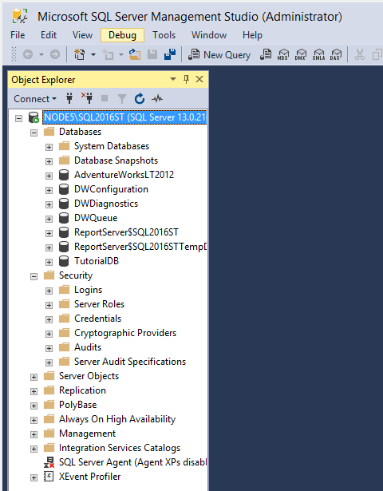

### QUERY WINDOW

We can execute the query and see results. Latest versions of SSMS comes with inteli sense.

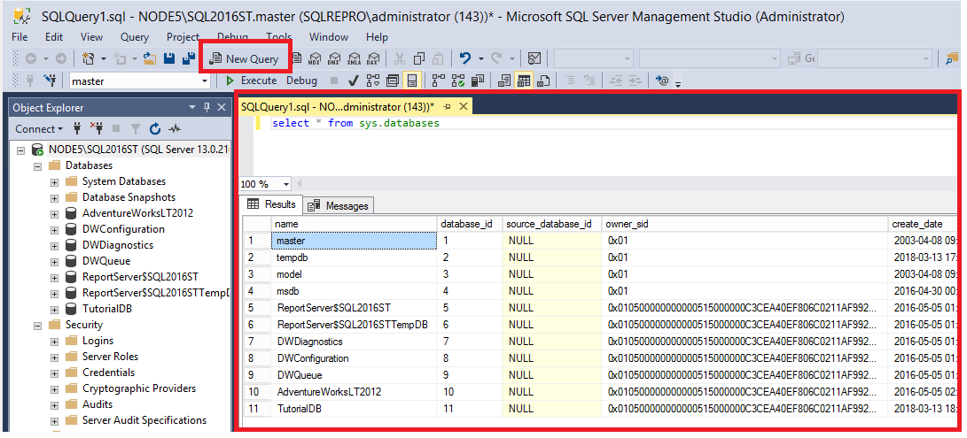

### PROPERTIES WINDOW

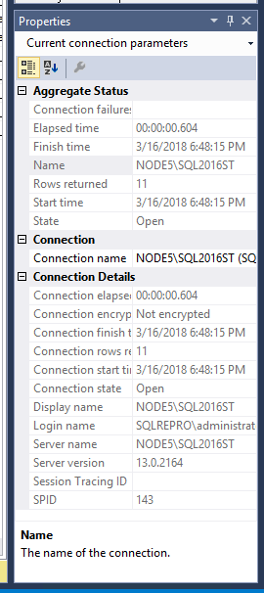

### TEMPLATE BROWSER

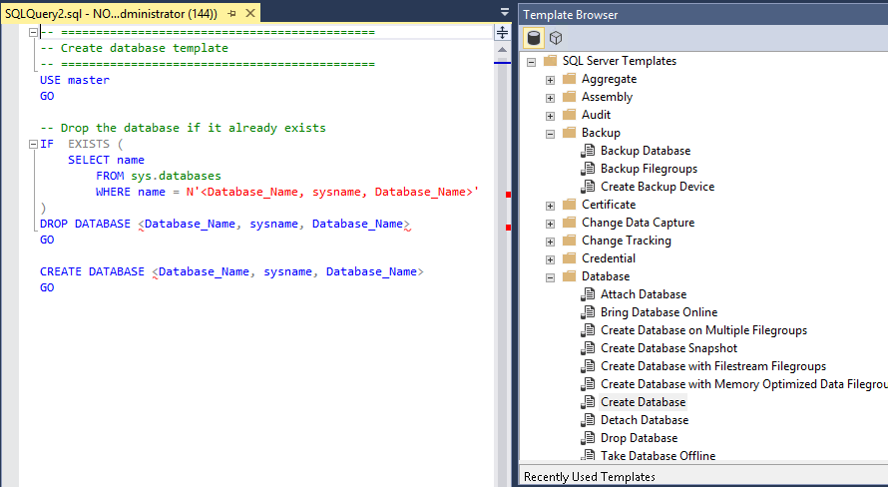

## USES OF SSMS

Some common uses of SSMS are:

* Create & maintain database.
* Create & maintain tables.
* Create & maintain other database objects like SP, VIEWS, Triggers etc.
* Create, maintain and schedule data backups.
* Replication (creating copy of database).
* Create and maintain user, roles etc.
* Optimization tasks.

## COLLATION

Collation defines how data is compared, stored and sorted within a database. Collation can be defined at different scopes:

* Server
* Database
* Columns
* Query

We can also change collations as per our need.

## QUERY EXECUTION ORDER

The order in which the query is evaluated by SQL Server is mentioned below:

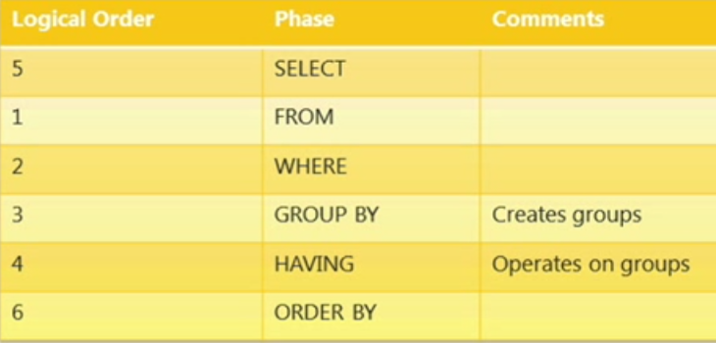

# INSTANCE DATABASES

By default, SQL Server has below system databases:

## MASTER DATABASE

Records all the instance -level information such as logins, Linked server names. If it is not available of corrupted then SQL will not be able to start.

## MODEL DATABASE

Is used as the template for all databases created on the instance of SQL Server. Modifications made to the **model** database, such as database size, collation, recovery model, and other database options, are applied to any databases created afterward. If it is not available of corrupted then SQL will not be able to start.

## MSDB DATABASE

Is used by SQL Server Agent for scheduling alerts and jobs.

## TEMPDB DATABASE

This database is a workspace for holding temporary objects or intermediate result sets. It also holds the version store. Recreated upon restart of the SQL Service.

## RESOURCE DATABASE

It was first introduced in SQL 2005. Is a read-only database that contains system objects that are included with SQL Server.

System objects are physically persisted in the **Resource** database, but they logically appear in the **sys** schema of every database.

## USER DEFINED DATABASES

In addition to System databases, a user can create his/ her own database using SSMS or CREATE Database TSQL statement. Using SSMS:

1. Open Microsoft SQL Management Studio
2. Connect to the database engine using database administrator credentials
3. Expand the server node
4. Right click Databases and select New Database
5. Enter a database name and click OK to create the database.

**Using TSQL: CREATE DATABASE database_name;**

The default values for database size, file size etc will be taken from the template available in MODEL database. An MDF file, known as the primary database file, which contains the schema and data.

LDF is a log file used with Microsoft SQL Server. All queries basically get stored here until successfully committed to the database (MDF). LDF files contain logging information for all transactions completed by the server.

## DATABASE VS SCHEMA

A database is the main container, it contains the data and log files, and all the schemas within it. You always back up a database.

Schemas are like folders within a database, and are mainly used to group logical objects together, which leads to ease of setting permissions by schema.

In simple terms, schemas are pretty much a collection of tables and databases are collections of schemas.

AS shown below, the Bike Stores sample database has two schemas sales and production, and these schemas have nine tables.

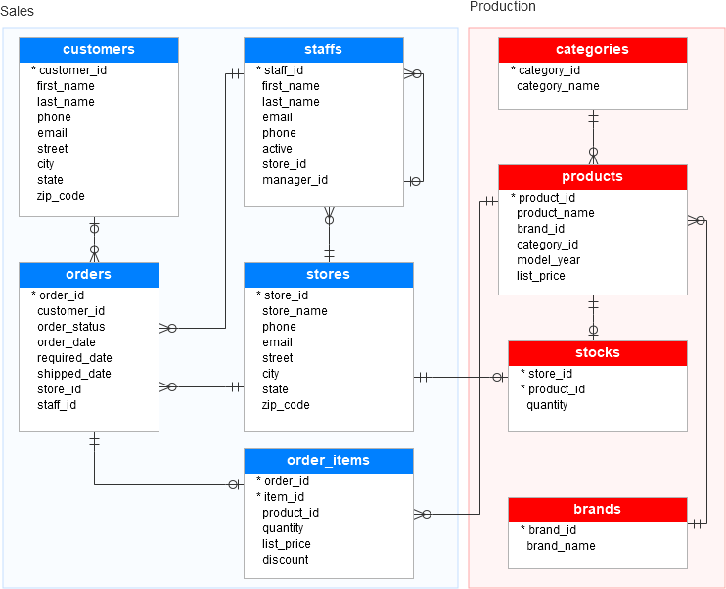

# VARIABLES

Variables are the object which acts as a placeholder.

MS SQL has two types of variables:

* Local variable
* Global variable

However, the user can only create a local variable. Below figure explain two types of variable available in MS SQL server.

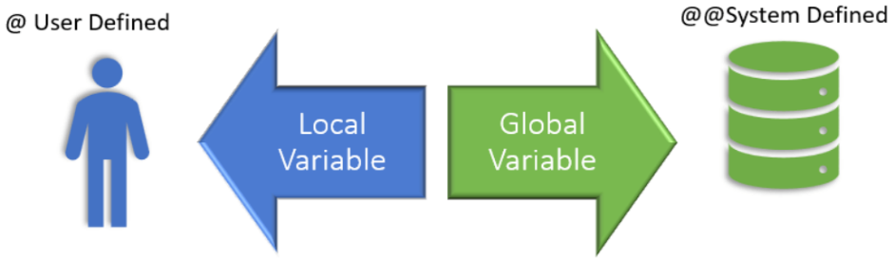

## LOCAL VARIABLE

* A user declares the local variable.
* By default, a local variable starts with @.
* Every local variable scope has the restriction to the current batch or procedure within any given session.

## GLOBAL VARIABLE

* The system maintains the global variable. A user cannot declare them.
* The global variable starts with @@
* It stores session related information.

## HOW TO DECLARE A VARIABLE

Before using any variable in batch or procedure, you need to declare the variable.

DECLARE command is used to DECLARE variable which acts as a placeholder for the memory location.

Only once the declaration is made, a variable can be used in the subsequent part of batch or procedure.



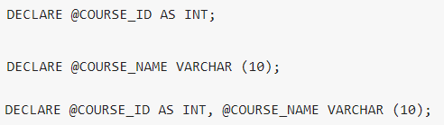

RULES

* Initialization is an optional thing while declaring.
* By default, DECLARE initializes variable to NULL.
* Using the keyword 'AS' is optional.
* To declare more than one local variable, use a comma after the first local variable definition, and then define the next local variable name and data type.

## ASSIGNING A VALUE TO A VARIABLE

We can assign a value to a variable in the following three ways:

* During variable declaration using DECLARE keyword.
* Using SET
* Using SELECT

From SQL Server 2008 onwards, we can declare and assign variables at the same time

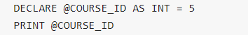

Sometimes we want to keep declaration and initialization separate. SET can be used to assign values to the variable, post declaring a variable. Below are the different ways to assign values using SET:

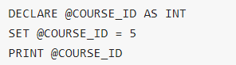

One SET Keyword can be used to assign a value to only one variable.

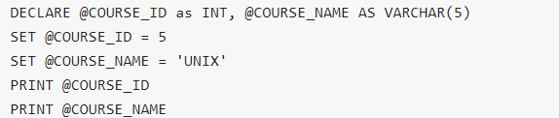

Just like SET, we can also use SELECT to assign values to the variables, post declaring a variable using DECLARE. Below are different ways to assign a value using SELECT:

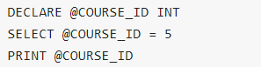

Unlike SET, SELECT can be used to assign a value to multiple variables separated by the comma.

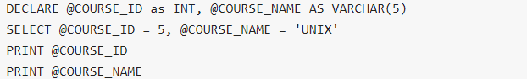

Rules:

* Unlike SET, if the query results in multiple rows then the variable value is set to the value of the last row.
* If the query returns zero rows, then the variable is set to EMPTY, i.e., NULL.
* Table Data type doesn't allow the use of 'AS' during declaration.
* SET complies with ANSI standards whereas SELECT does not.

Creating a local variable with the name as @ is also allowed. We can declare it as, for example.



# DATA TYPE IN SQL SERVER

The following picture illustrates the SQL Server data types system:

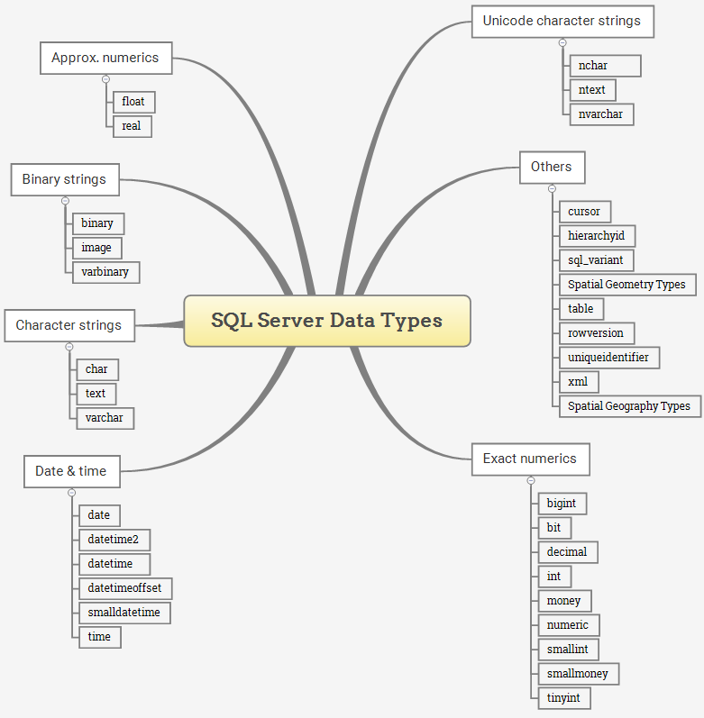

Unicode is a standard for representing characters as integers. Unlike ASCII, which uses 7 bits for each character, Unicode uses 16 bits, which means that it can represent more than 65,000 unique characters. It is necessary for few languages like Greek, Chinese and Japanese.

* Nchar
* Nvarchar (Unicode strings)
* Ntext (will be depreciated in coming versions, use nvarchar(max) instead)

If we want to store special language characters then we should use nvarchar or nchar as they have the ability to store special characters which varchar and char cannot store. If we store special characters in varchar or char then we will get ‘?’ if we print the special character.

Below is the various date and time formats that we can use in SQL Server. By default the date format is YYYY:MM:DD

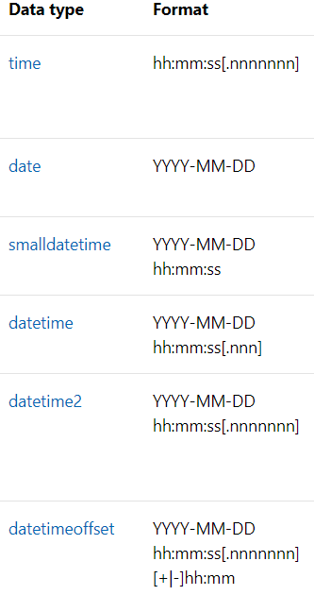

The DATETIMEOFFSET allows you to manipulate any single point in time, which is a datetime value, along with an offset that specifies how much that datetime differs from UTC.

# CONVERTING DATA TYPES

We have below functions that can be used for data type conversion:

## CAST

It follows ANSI Standard. Portable with different RDBMS.

## CONVERT

Available only in SQL Server. Not portable with different RDBMS.

## PARSE

New function in SQL 2012 that converts strings to date, time and numbers types. It should only be used while converting strings to datetime format or number format.

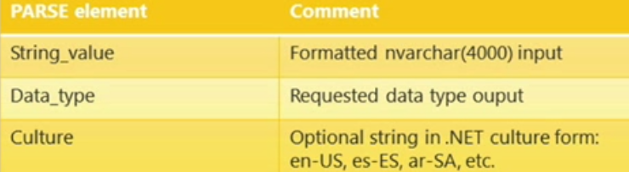



## TRY_CONVERT

Structured error handling if conversion fails. It will return NULL if conversion fails.

## TRY_PARSE

It depends on the installation of .NET CLR. Structured error handling if conversion fails. It will return NULL if conversion fails. Does have extra overhead compared to TRY_CONVERT.

# MS - SQL

SQL is a standard language for accessing and manipulating databases. We can use SQL for following

* SQL can execute queries against a database
* SQL can retrieve data from a database
* SQL can insert records in a database
* SQL can update records in a database
* SQL can delete records from a database
* SQL can create new databases
* SQL can create new tables in a database
* SQL can create stored procedures in a database
* SQL can create views in a database
* SQL can set permissions on tables, procedures, and views

In short whatever tasks we can perform with SSMS can be achieved via T-SQL as well.

## TYPE OF TSQL COMMANDS

We have following type of T – SQL commands as shown below:

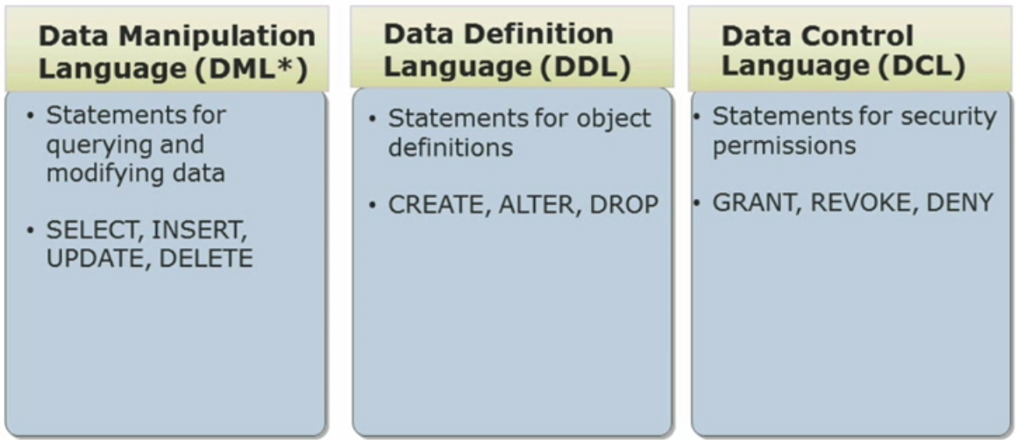

## ADDING COMMENTS

We can add comments to T – SQL code using /* or –

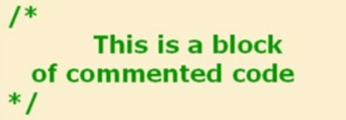



## STRING CONCATENATION

We can use + sign to concatenate two strings. Concatenating a value with NULL returns NULL

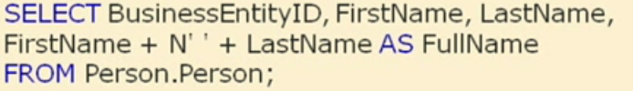

SQL Server 2012 introduced CONCAT () function. It converts NULL to an empty string before concatenation.

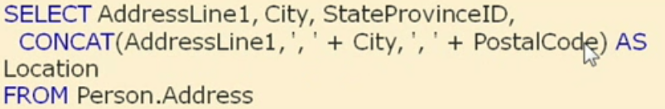

# ALIAS

SQL aliases are used to give a table, or a column in a table, a temporary name. Aliases are often used to make column names more readable.

An alias only exists for the duration of the query.

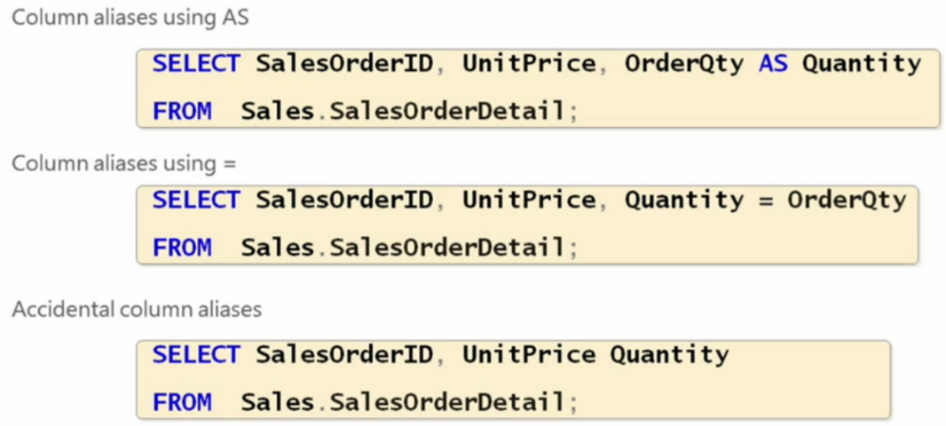

Using aliases to refer tables

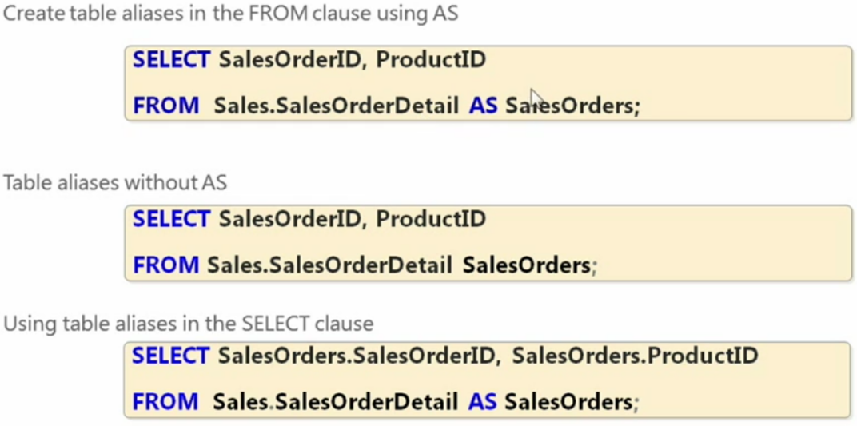

We can use column Alias in Order by clause only as ORDER BY is evaluated after SELCT statement by SQL Server and hence it makes sense.

# GUID

A globally unique identifier or GUID is a broader version of this type of ID numbers. A GUID is guaranteed to be unique across tables, databases, and even servers.

In SQL Server, GUID is 16-byte binary data type, which is generated by using the NEWID() function:

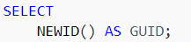

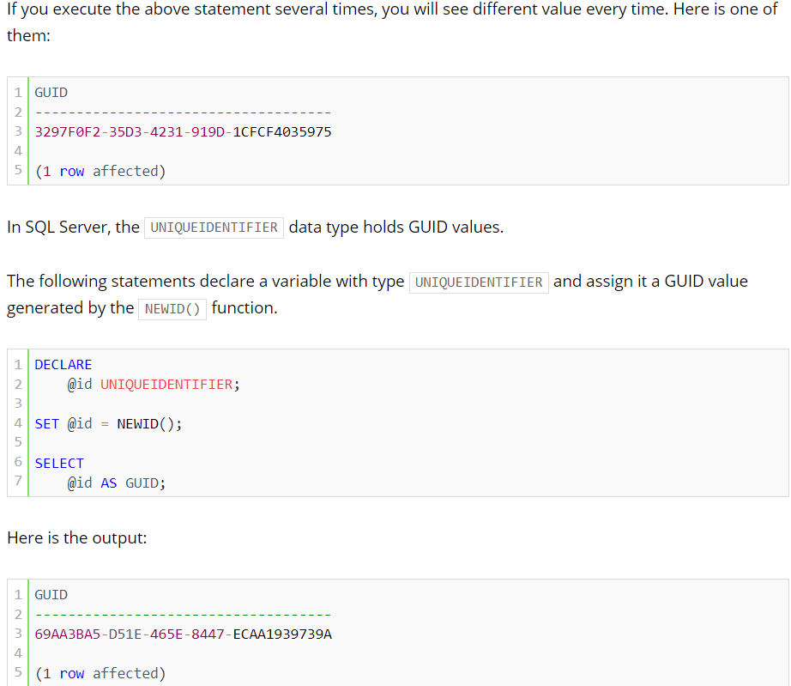

Sometimes, it prefers using GUID values for the primary key column of a table than using integers.

Using GUID as the primary key of a table brings the following advantages:

* GUID values are globally unique across tables, databases, and even servers. Therefore, it allows you to merge data from different servers with ease.
* GUID values do not expose the information so they are safer to use in public interface such as a URL.

Besides these advantages, storing GUID in the primary key column of a table has the following disadvantages:

* GUID values (16 bytes) takes more storage than INT (4 bytes) or even BIGINT (8 bytes)
* GUID values make it difficult to troubleshoot and debug, comparing WHERE id = 100 with WHERE id = 'F4AB02B7-9D55-483D-9081-CC4E3851E851'.

# QUERYING DATA

To query data from a table, you use the SELECT statement. The following illustrates the most basic form of the SELECT statement:

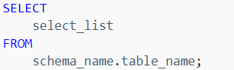

When processing the SELECT statement, SQL Server processes the FROM clause first and then the SELECT clause even though the SELECT clause appears first in the query.

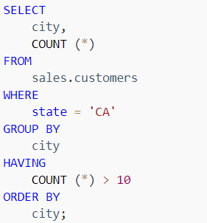

Notice that the WHERE clause filters rows while the HAVING clause filter groups. Also windowed functions can only appear in SELECT clause.

# MODIFYING DATA

We can modify data in the database using following commands

## INSERT

To add one or more rows into a table, you use the INSERT statement.

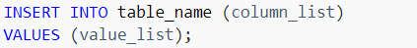

First, you specify the name of the table which you want to insert.

Second, you specify a list of one or more columns in which you want to insert data. If a column of a table does not appear in the column list, SQL Server must be able to provide a value for insertion or the row cannot be inserted.

SQL Server automatically uses the following value for the column that is available in the table but does not appear in the column list of the INSERT statement:

* The next incremental value if the column has an IDENTITY property.
* The default value if the column has a default value specified.
* The current timestamp value if the data type of the column is a timestamp data type.
* The NULL if the column is nullable.
* The calculated value if the column is a computed column.

Third, you provide a list of values to be inserted in the VALUES clause. Each column in the column list must have a corresponding value in the value list. Also, you must enclose the value list in parentheses.

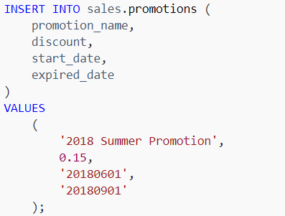

To capture the inserted values, you use the OUTPUT clause.

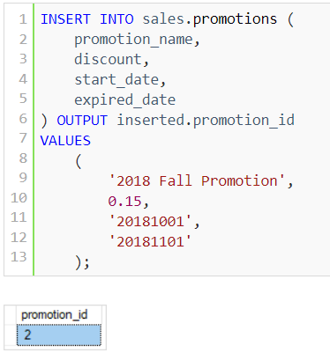

To capture inserted values from multiple columns, you specify the columns in the output as shown in the following statement:

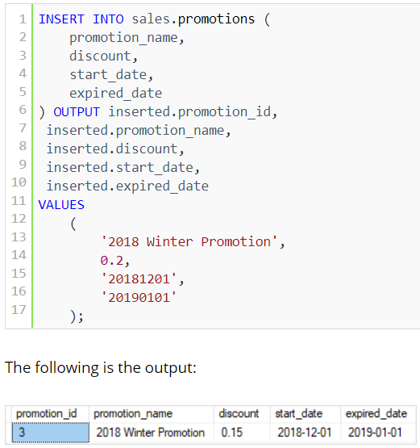

Typically, you don’t specify a value for the identity column because SQL Server will provide the value automatically.

However, in some situations, you may want to insert a value into the identity column such as data migration.

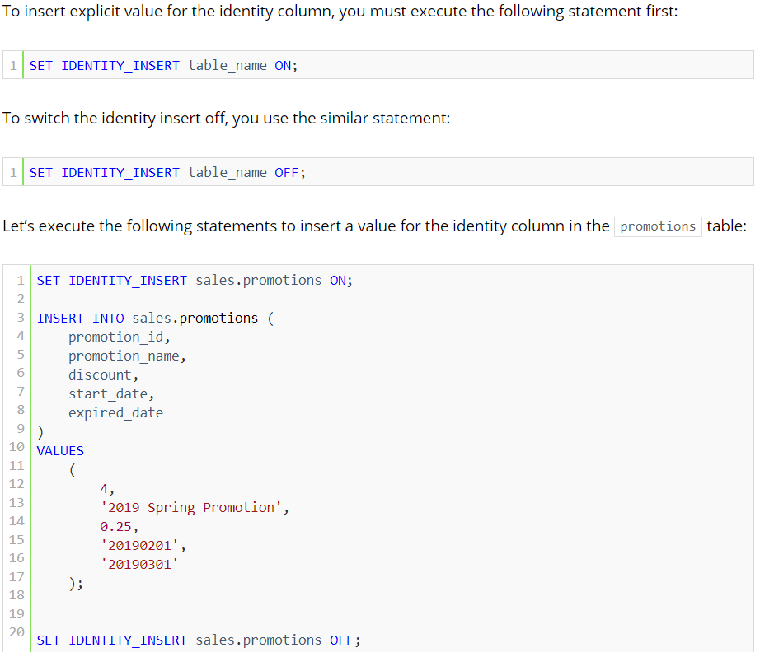

## INSERT INTO SELECT

To insert data from other tables into a table, you use the following SQL Server INSERT INTO SELECT statement:

In this syntax, the statement inserts rows returned by the query into the target_table.

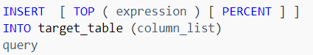

The query is any valid SELECT statement that retrieves data from other tables. It must return the values that are corresponding to the columns specified in the column_list.

The TOP clause part is optional. It allows you to specify the number of rows returned by the query to be inserted into the target table. If you use the PERCENT option, the statement will insert the percent of rows instead. Note that it is a best practice to always use the TOP clause with the ORDER BY clause.

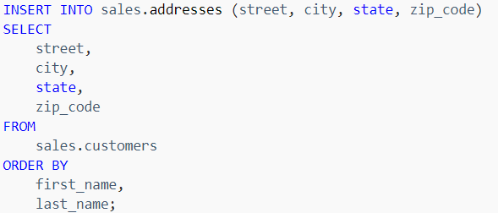

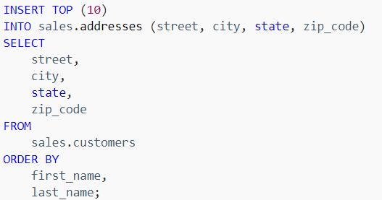

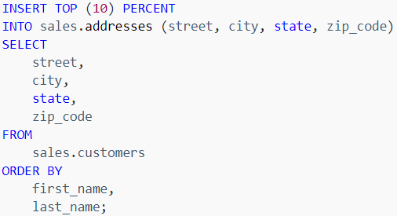

## UPDATE

To modify existing data in a table, you use the following UPDATE statement:

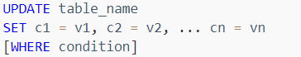

In this syntax:

* First, specify the name of the table from which the data is to be updated.
* Second, specify a list of columns c1, c2, …, cn and values v1, v2, … vn to be updated.
* Third, specify the conditions in the WHERE clause for selecting the rows that are updated. The WHERE clause is optional. If you skip the WHERE clause, all rows in the table are updated.

Below syntax updates all the rows of a column

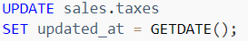

Updating multiple columns of a table:

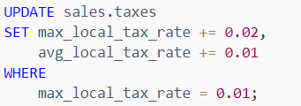

## UPDATE JOIN

To query data from related tables, you often use the join clauses, either inner join or left join. In SQL Server, you can use these join clauses in the UPDATE statement to perform a cross-table update.

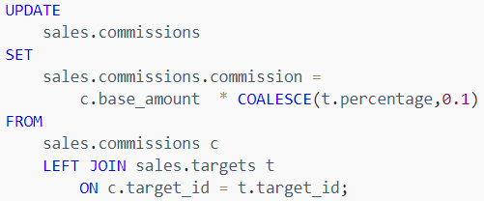

In this example, we used COALESCE() to return 0.1 if the percentage is NULL.

## DELETE

To remove one or more rows from a table completely, you use the DELETE statement. The following illustrates its syntax:

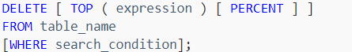

The WHERE clause is optional. If you skip it, the DELETE statement will remove all rows from the table.

The following DELETE statement removes 21 random rows from the product_history table:

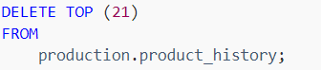

The following DELETE statement removes 5 percent of random rows from the product_history table:

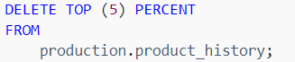

The following DELETE statement removes all products whose model year is 2017:

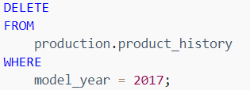

The following DELETE statement removes all rows from the product_history table:

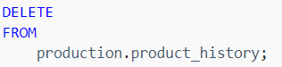

Note that if you want to remove all rows from a big table, you should use the TRUNCATE TABLE statement which is faster and more efficient.

## MERGE

Suppose, you have two table called source and target tables, and you need to update the target table based on the values matched from the source table. There are three cases:

* The source table has some rows that do not exist in the target table. In this case, you need to insert rows that are in the source table into the target table.
* The target table has some rows that do not exist in the source table. In this case, you need to delete rows from the target table.
* The source table has some rows with the same keys as the rows in the target table. However, these rows have different values in the non-key columns. In this case, you need to update the rows in the target table with the values coming from the source table.

The following picture illustrates the source and target tables with the corresponding actions: insert, update, and delete:

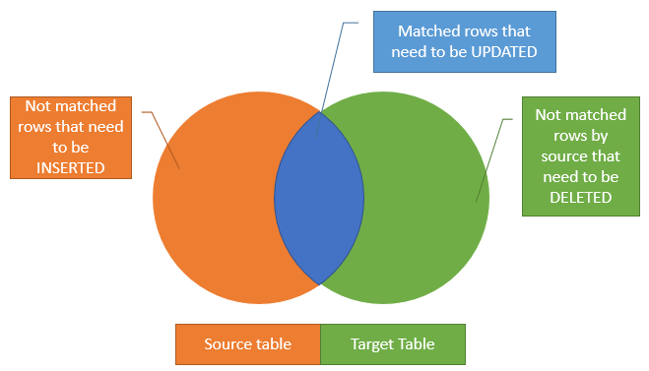

If you use the INSERT, UPDATE, and DELETE statement individually, you have to construct three separate statements to update the data to the target table with the matching rows from the source table.

However, SQL Server provides the MERGE statement that allows you to perform three actions at the same time. The following shows the syntax of the MERGE statement:

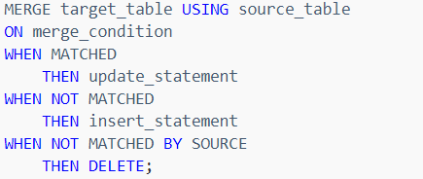

First, you specify the target table and the source table in the MERGE clause.

Second, the merge_condition determines how the rows from the source table are matched to the rows from the target table. It is similar to the join condition in the join clause. Typically, you use the key columns either primary key or unique key for matching.

Third, the merge_condition results in three states: MATCHED, NOT MATCHED, and NOT MATCHED BY SOURCE.

* **MATCHED**: these are the rows that match the merge condition. In the diagram, they are shown as blue. For the matching rows, you need to update the rows columns in the target table with values from the source table.
* **NOT MATCHED**: these are the rows from the source table that does not have any matching rows in the target table. In the diagram, they are shown as orange. In this case, you need to add the rows from the source table to the target table. Note that NOT MATCHED is also known as NOT MATCHED BY TARGET.
* **NO MATCHED BY SOURCE**: these are the rows in the target table that does not match any rows in the source table. They are shown as green in the diagram. If you want to synchronize the target table with the data from the source table, then you will need to use this match condition to delete rows from the target table.

Let’s consider an example:

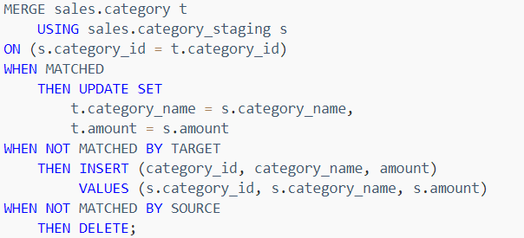

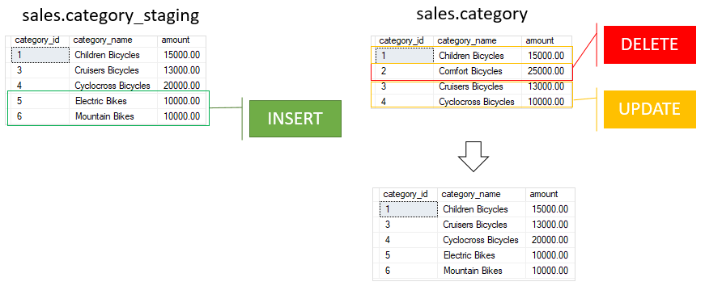

In this example, we used the values in the category_id columns in both tables as the merge condition.

* First, the rows with id 1, 3, 4 from the sales.category_staging table matches with the rows from the target table, therefore, the MERGE statement updates the values in category name and amount columns in the sales.category table.
* Second, the rows with id 5 and 6 from the sales.category_staging table do not exist in the sales.category table, so the MERGE statement inserts these rows into the target table.
* Third, the row with id 2 from the sales.category table does not exist in the sales.sales_staging table, therefore, the MERGE statement deletes this row.

As a result of the merger, the data in the sales.category table is fully synchronized with the data in the sales.category_staging table.

# SORTING DATA

When you use the SELECT statement to query data from a table, the order of rows in the result set is not guaranteed. It means that SQL Server can return a result set with an unspecified order of rows.

The only way for you to guarantee that the rows in the result set are sorted is to use the ORDER BY clause. The following illustrates the ORDER BY clause syntax:

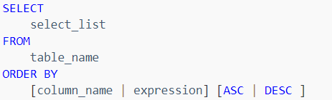

By default, ORDER BY clause sort the result set in ascending order.

We can also sort a result set by multiple columns and different orders. The following statement sorts the customers by the city in descending order and the sort the sorted result set by the first name in ascending order.

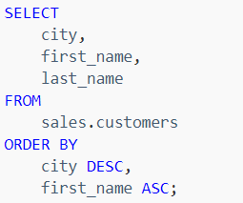

It is also possible to sort the result set by a column that does not appear on the select list.

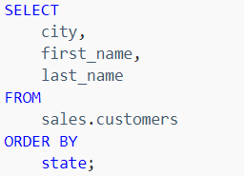

We can also sort a result set by an expression:

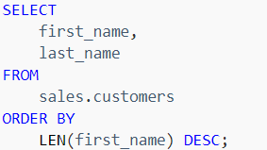

SQL Server allows you to sort the result set based on the ordinal positions of columns that appear in the select list.

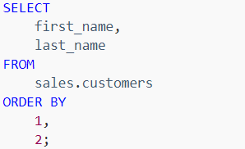

# LIMITING ROWS

We can use the SQL Server OFFSET FETCH clauses to limit the number of rows returned by a query.

## OFFSET FETCH

The OFFSET and FETCH clauses are the options of the ORDER BY clause. They allow you to limit the number of rows to be returned by a query.

The following illustrates the syntax of the OFFSET and FETCH clauses:

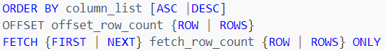

* The OFFSET clause specifies the number of rows to skip before starting to return rows from the query.
* The FETCH clause specifies the number of rows to return after the OFFSET clause has been processed.
* The OFFSET clause is mandatory while the FETCH clause is optional.

The following illustrates the OFFSET and FETCH clauses:

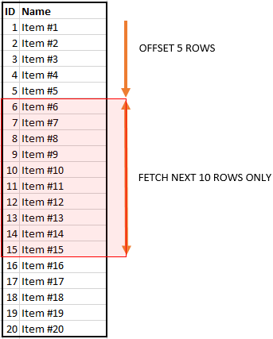

Note that you must use the OFFSET and FETCH clauses with the ORDER BY clause. Otherwise, you will get an error. Let’s take an example:

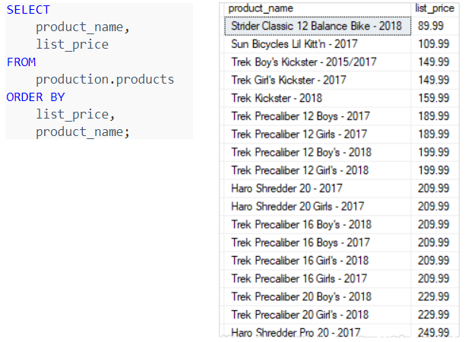

To skip the first 10 products and return the rest, you use the OFFSET clause as shown in the following statement:

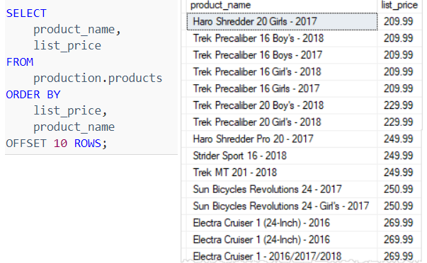

To skip the first 10 products and select the next 10 products, you use both OFFSET and FETCH clauses as follows:

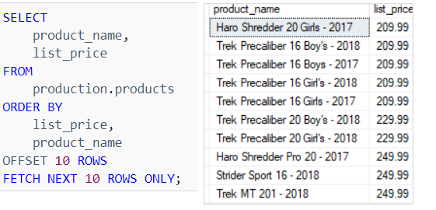

To get the top 10 most expensive products you use both OFFSET and FETCH clauses:

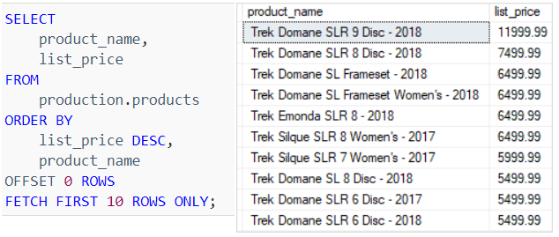

## TOP

The SELECT TOP clause allows you to limit the number of rows or percentage of rows returned in a query result set.

Because the order of rows stored in a table is unpredictable, the SELECT TOP statement is always used in conjunction with the ORDER BY clause.

The following shows the syntax of the TOP clause with the SELECT statement:

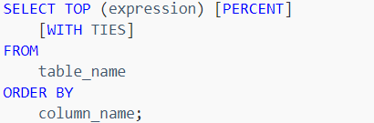

Following the TOP keyword is an expression that specifies the number of rows to be returned. The expression is evaluated to a float value if PERCENT is used, otherwise, it is converted to a BIGINT value

The PERCENT keyword indicates that the query returns the first N percentage of rows, where N is the result of the expression.

The WITH TIES allows you to return more rows with values match the last row in the in the limited result set. Note that WITH TIES may cause more rows to be returned than you specify in the expr

Using TOP with a constant value:

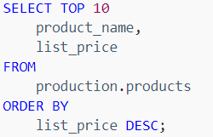

Using TOP to return a percentage of rows

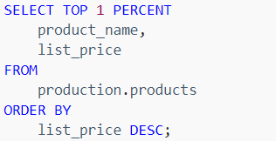

Using TOP WITH TIES to include rows that match the values in the last row

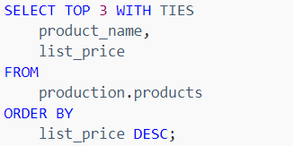

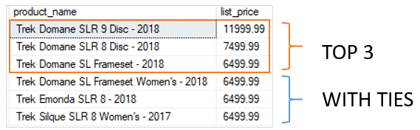

# FILTERING DATA

We can filter data using below clauses in SQL Server

## DISTINCT

Sometimes, you may want to get only distinct values in a specified column of a table. To do this, you use the SELECT DISTINCT clause as follows:

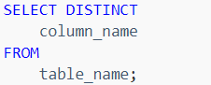

The query returns only distinct values in the specified column. In other words, it removes the duplicate values in the column from the result set.

If you use multiple columns as follows:

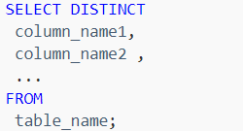

The query uses the combination of values in all specified columns in the SELECT list to evaluate the uniqueness.

If you apply the DISTINCT clause to a column that has NULL, the DISTINCT clause will keep only one NULL and eliminates the other. In other words, the DISTINCT clause treats all NULL “values” as the same value.

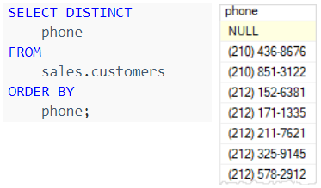

Both DISTINCT and GROUP BY clause reduces the number of returned rows in the result set by removing the duplicates.

However, you should use the GROUP BY clause when you want to apply an aggregate function on one or more columns.

## WHERE

When you use the SELECT statement to query data against a table, you get all the rows of that table, which is unnecessary because the application may only process a set of rows at the time.

To get the rows from the table that satisfy one or more conditions, you use the WHERE clause as follows:

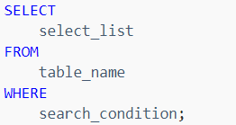

In the WHERE clause, you specify a search condition to filter rows returned by the FROM clause. The WHERE clause only returns the rows that cause the search condition to evaluate to TRUE. The search condition is a logical expression or a combination of multiple logical expressions. In SQL, a logical expression is often called a predicate.

## HAVING

The HAVING clause is often used with the GROUP BY clause to filter groups based on a specified list of conditions. The following illustrates the HAVING clause syntax:

Because SQL Server processes the HAVING clause after the GROUP BY clause, you cannot refer to the aggregate function specified in the select list by using the column alias.

Because SQL Server processes the HAVING clause after the GROUP BY clause, you cannot refer to the aggregate function specified in the select list by using the column alias.

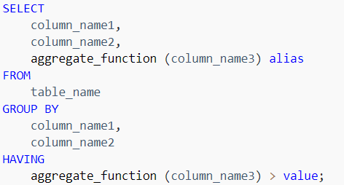

The following statement first finds the maximum and minimum list prices in each product category. Then, it filters out the category which has the maximum list price greater than 4,000 or the minimum list price less than 500:

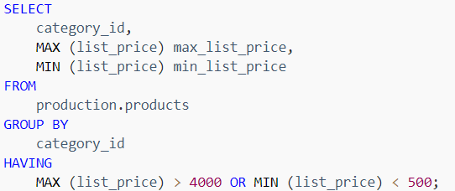

# GROUPING DATA

In this section we will learn how we can group data in SQL Server.

## GROUP BY

The GROUP BY clause allows you to arrange the rows of a query in groups. The groups are determined by the columns that you specify in the GROUP BY clause.

Consider the following example:

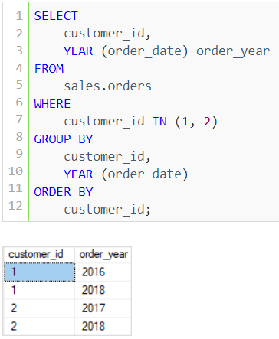

In this example, we retrieved the customer id and the ordered year of the customers with the customer id one and two.

## GROUP BY & AGGREGATE FUNCTIONS

In practice, the GROUP BY clause is often used with aggregate functions for generating summary reports.

An aggregate function performs a calculation on a group and returns a unique value per group. For example, COUNT () function returns the number of rows in each group. Other commonly used aggregate functions are SUM (), AVG () (average), MIN (), MAX ().

The GROUP BY clause arranges rows into groups and an aggregate function returns the summary (count, min, max, average, sum, etc.,) for each group.

For example, the following query returns the number of orders placed by the customer by year:

GROUP For example, the following query returns the number of orders placed by the customer by year: BY clause and aggregate functions

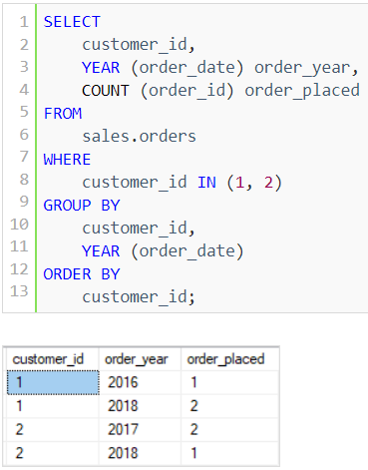

If you want to refer to any column or expression that is not listed in the GROUP BY clause, you must use that column as the input of an aggregate function. Otherwise, you will get an error because there is no guarantee that the column or expression will return a single value per group.

## GROUPING SETS

By definition, a grouping set is a group of columns by which you group. Typically, a single query with an aggregate defines a single grouping set.

For example, the following query defines a grouping set that includes brand and category which is denoted as (brand, category). The query returns the sales amount grouped by brand and category:

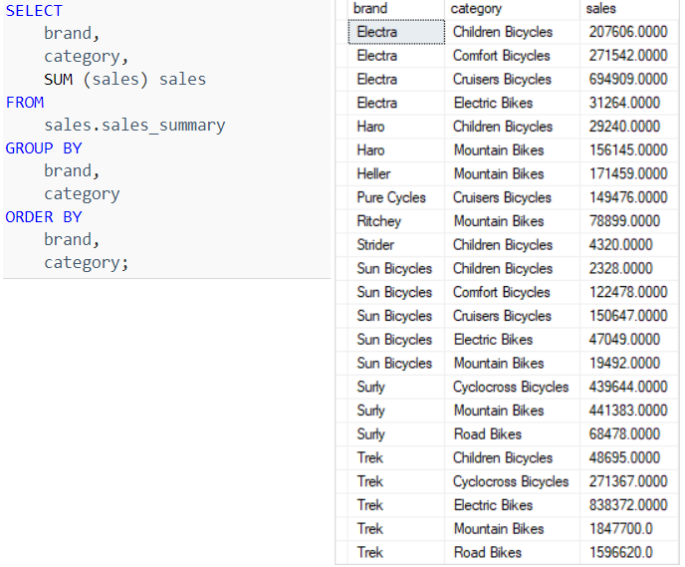

The following query returns the sales amount by brand. It defines a grouping set (brand):

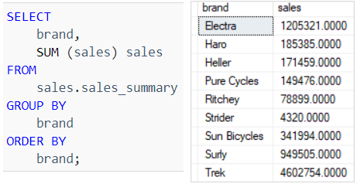

The following query returns the sales amount by category. It defines a grouping set (category):

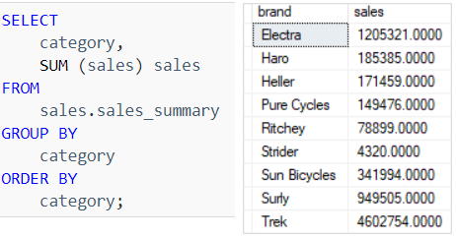

The following query defines an empty grouping set (). It returns the sales amount for all brands and categories.

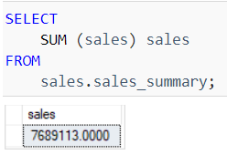

The four queries above return four result sets with four grouping sets:

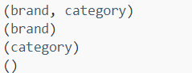

The GROUPING SETS is a sub clause that defines multiple grouping sets in the same query. The following shows the general syntax of the GROUPING SETS:

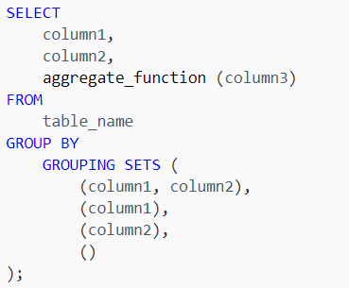

This query creates four grouping sets:

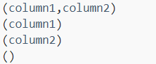

## GROUPING FUNCTION

The GROUPING function indicates whether a specified column in a GROUP BY clause is aggregated or not. It returns 1 for aggregated or 0 for not aggregated in the result set.

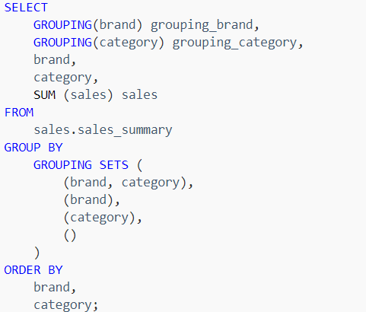

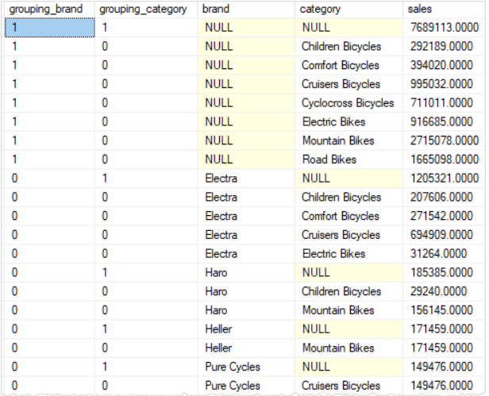

The value in the grouping_brand column indicates that the row is aggregated or not, 1 means that the sales amount is aggregated by brand, 0 means that the sales amount is not aggregated by brand. The same concept is applied to the grouping_category column.

## CUBE

The CUBE is a subclause of the GROUP BY clause that allows you to generate multiple grouping sets.

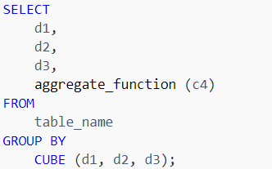

In this syntax, the CUBE generates all possible grouping sets based on the dimension columns d1, d2, and d3 that you specify in the CUBE clause.

The above query returns the same result set as the following query, which uses the GROUPING SETS:

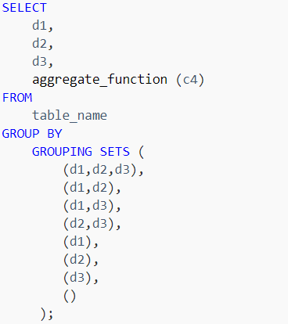

If you have N dimension columns specified in the CUBE, you will have 2N grouping sets.

It is possible to reduce the number of grouping sets by using the CUBE partially as shown in the following query:

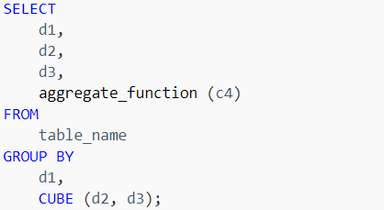

In this case, the query generates four grouping sets because there are only two-dimension columns specified in the CUBE.

## ROLLUP

The SQL Server ROLLUP is a subclause of the GROUP BY clause which provides a shorthand for defining multiple grouping sets. Unlike the CUBE subclause, ROLLUP does not create all possible grouping sets based on the dimension columns; the CUBE makes a subset of those.

When generating the grouping sets, ROLLUP assumes a hierarchy among the dimension columns and only generates grouping sets based on this hierarchy.

The ROLLUP is often used to generate subtotals and totals for reporting purposes.

The ROLLUP (d1, d2, d3) creates only four grouping sets, assuming the hierarchy d1 > d2 > d3, as follows

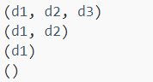

In this syntax, d1, d2, and d3 are the dimension columns.

The ROLLUP is commonly used to calculate the aggregates of hierarchical data such as sales by year > quarter > month.

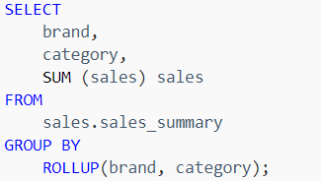

In this example, the query assumes that there is a hierarchy between brand and category, which is the brand > category.

Note that if you change the order of brand and category, the result will be different

The following statement shows how to perform a partial roll-up:

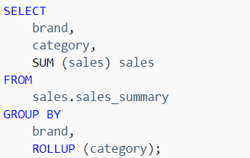

# LOGICAL OPERATOR

Below are some important logical operators in SQL Server

## AND

The AND is a logical operator that allows you to combine two Boolean expressions. It returns TRUE only when both expressions evaluate to TRUE.

Note that SQL Server uses three-valued predicate logic where a logical expression can evaluate to TRUE, FALSE, or UNKNOWN. The WHERE clause will not return any row that causes the predicate evaluates to FALSE or UNKNOWN.

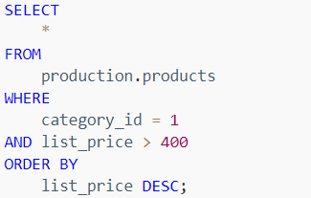

In below example, we used both OR & AND operators in the condition. As always, SQL Server evaluated the AND operator first. Therefore, the query retrieved the products whose brand id is two and list price is greater than 1,000 or the products whose brand id is one.

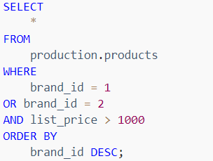

To get the product whose brand id is one or two and list price is larger than 1,000, you use parentheses as follows:

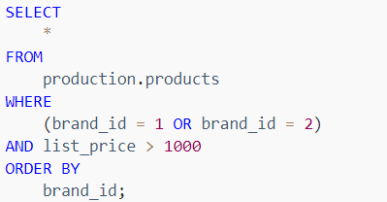

## OR

The SQL Server OR is a logical operator that allows you to combine two Boolean expressions. It returns TRUE when either of the conditions evaluates to TRUE.

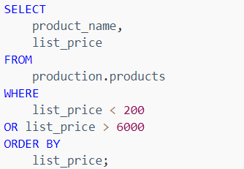

The following statement finds the products whose brand id is 1, 2, or 4:

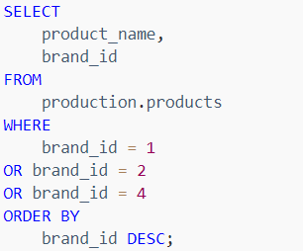

## IN

The IN operator is a logical operator that allows you to test whether a specified value matches any value in a list.

If a value in the column or the expression is equal to any value in the list, the result of the IN operator is TRUE.

The IN operator is equivalent to multiple OR operators, therefore, the following predicates are equivalent:

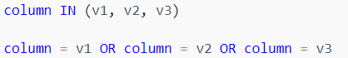

To negate the IN operator, you use the NOT IN operator as follows:



We can also use subquery with IN clause as shown in the following query:

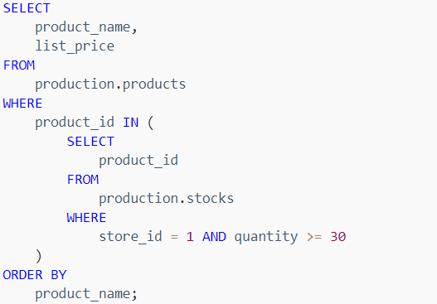

## BETWEEN

The BETWEEN operator is a logical operator that allows you to specify a range to test.

The BETWEEN operator returns TRUE if the expression to test is greater than or equal to the value of the start_expression and less than or equal to the value of the end_expression.

The condition that uses the BETWEEN operator is much more readable the one that uses the comparison operators >=, <= and the logical operator AND.

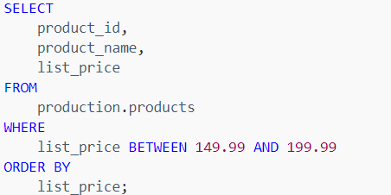

To get the products whose list prices are in the range 149.99 and 199.99, you use the NOT BETWEEN operator as follows:

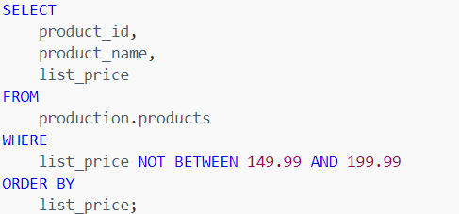

The following query finds the orders that customers placed between January 15, 2017 and January 17, 2017:

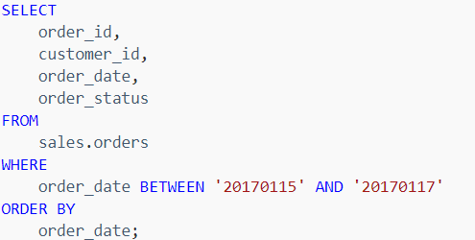

## LIKE

The SQL Server LIKE is a logical operator that determines if a character string matches a specified pattern. A pattern may include regular characters and wildcard characters. The LIKE operator is used in the WHERE clause of the SELECT, UPDATE, and DELETE statements to filter rows based on pattern matching.

The following illustrates the syntax of the SQL Server LIKE operator:



The pattern is a sequence of characters to search for in the column or expression. It can include the following valid wildcard characters:

* The percent wildcard (%): any string of zero or more characters.
* The underscore (_) wildcard: any single character.
* The [list of characters] wildcard: any single character within the specified set.
* The [character-character]: any single character within the specified range.
* The [^]: any single character not within a list or a range.

The following example finds the customers whose last name starts with the letter z:

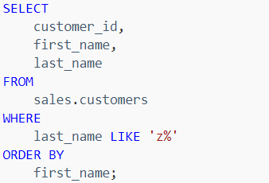

The following example returns the customers whose last name ends with the string er:

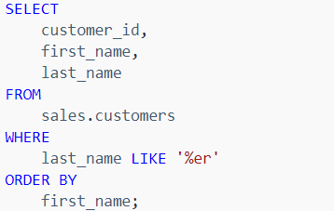

The following statement retrieves the customers whose last name starts with the letter t and ends with the letter s:

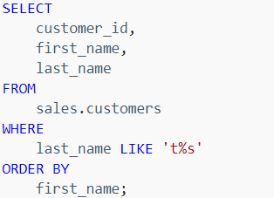

The underscore represents a single character. For example, the following statement returns the customers where the second character is the letter u:

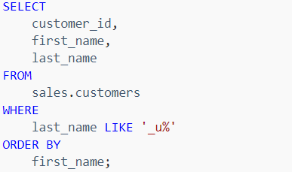

The square brackets with a list of characters e.g. [ABC]represent a single character that must be one of the characters specified in the list.

For example, the following query returns the customers where the first character in the last name is Y or Z:

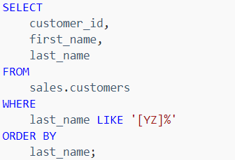

The square brackets with a character range e.g., [A-C] represent a single character that must be within a specified range.

For example, the following query finds the customers where the first character in the last name is the letter in the range A through C:

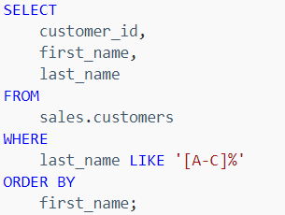

The square brackets with a caret sign (^) followed by a range e.g., [^A-C] or character list e.g., [ABC] represent a single character that is not in the specified range or character list.

For example, the following query returns the customers where the first character in the last name is not the letter in the range A through X:

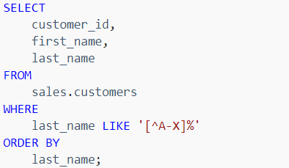

The following example uses the NOT LIKE operator to find customers where the first character in the first name is not the letter A:

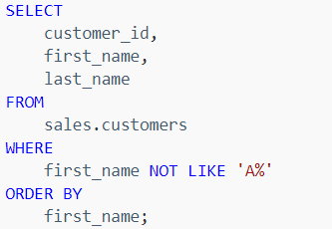

# CASE STATEMENT

CASE is the extension of IF...ELSE statement. Unlike IF…ELSE, where only the maximum of one condition is allowed, CASE allows the user to apply multiple conditions to perform different sets of actions in MS SQL.

In MS SQL, there are two types of CASE:

* Simple CASE
* Searched CASE

## SIMPLE CASE

In simple case statement we can only check whether the expression is equal to a particular value or not. Below is an example of simple case statement

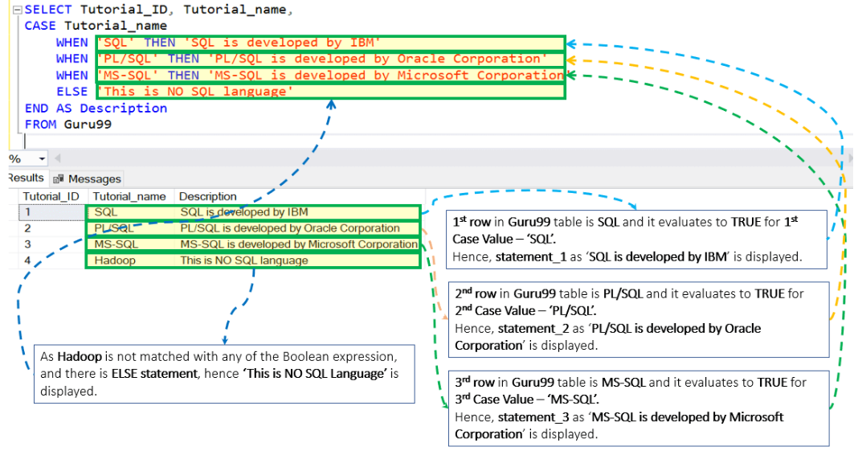

ELSE is optional. If ELSE is not present and Case_Expression matches with none of the values, then Null will be displayed.

## SEARCHED CASE

Unlike the simple case, Searched Case is not restricted to only equality check but allows Boolean expression.

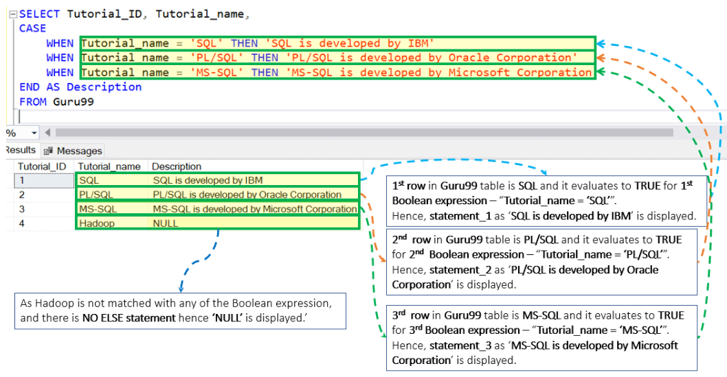

## NESTED CASE STATEMENTS

We can use CASE statement inside IF ELSE

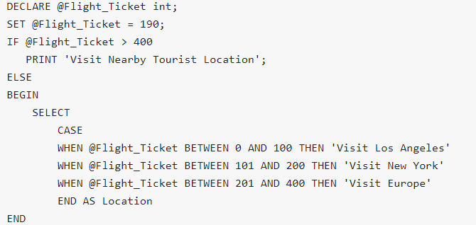

We can also use case statement inside another case statement

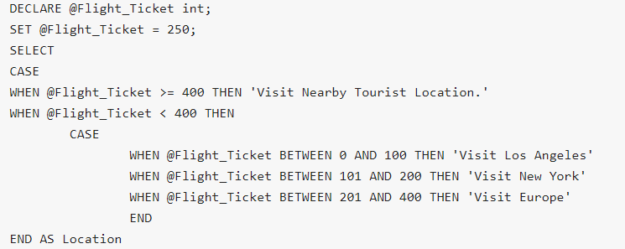

We can use CASE statement with UPDATE

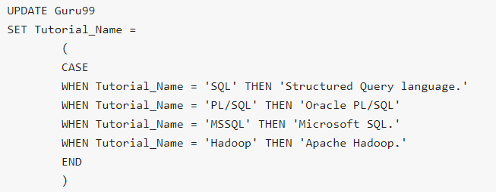

We can also use CASE statement with ORDR BY

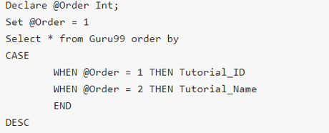

# JOINS

A JOIN clause is used to combine retrieve data from two or more tables, based on a related column between them.

Most queries using a join can be rewritten using a subquery (a query nested within another query), and most subqueries can be rewritten as joins.

SQL Server supports many kinds of joins including inner join, left join, right join, full outer join, and cross join. Each join type specifies how SQL Server uses data from one table to select rows in another table.

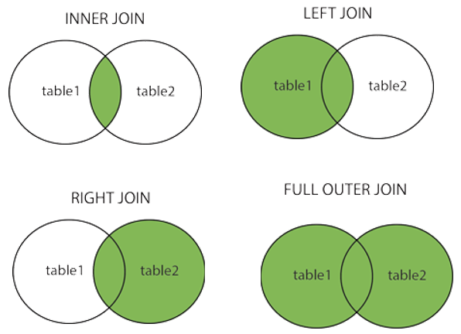

* Inner joins can be specified in either the FROM or WHERE clauses.
* Outer joins can be specified in the FROM clause only.
* The join conditions combine with the WHERE and HAVING search conditions to control the rows that are selected from the base tables referenced in the FROM clause.
* Cross joins are used to create all possible combinations for two tables. For example, table a has colors and table b has size, then we can use cross product to create all possible combinations.

If you want to fetch non-matching rows from right and left table then do a FULL JOIN and select the records having null in matching column and having null in another column.

## INNER JOIN

Inner join produces a data set that includes rows from the left table which have matching rows from the right table.

The following example uses the inner join clause to get the rows from the candidates table that have the corresponding rows with the same values in the fullname column of the employees table:

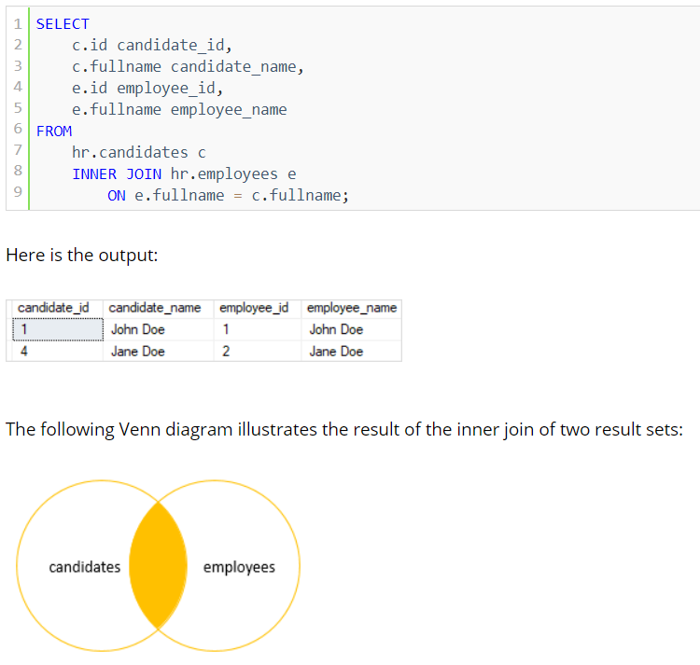

## LEFT JOIN

Left join selects data starting from the left table and matching rows in the right table. The left join returns all rows from the left table and the matching rows from the right table. If a row in the left table does not have a matching row in the right table, the columns of the right table will have nulls.

The left join is also known as left outer join. The outer keyword is optional.

The following statement joins the candidates table with the employees table using left join:

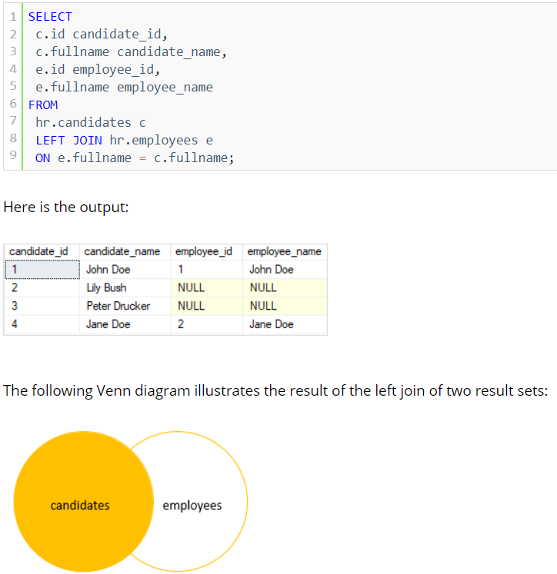

To get the rows that available only in the left table but not in the right table, you add a WHERE clause to the above query:

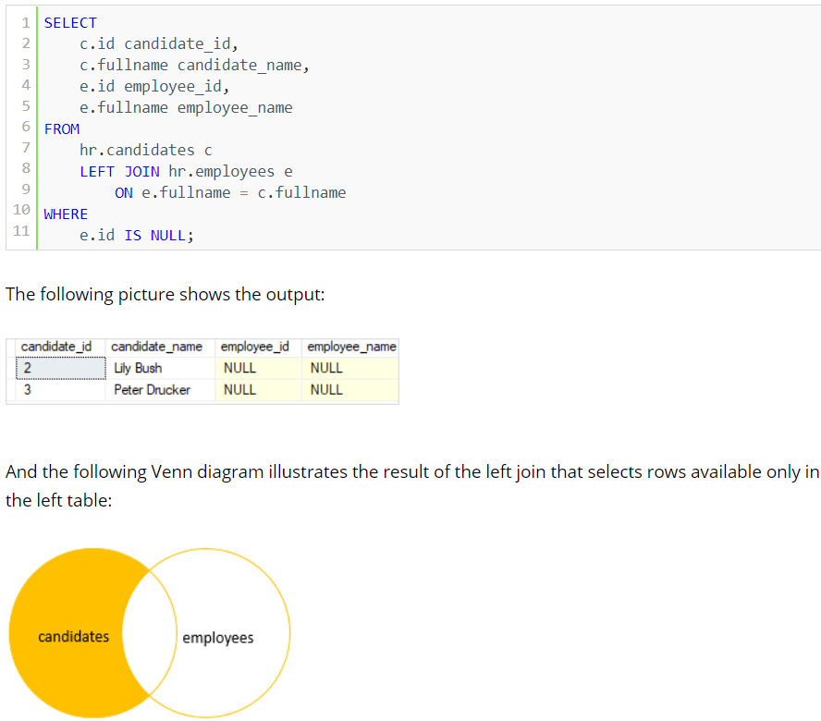

## RIGHT JOIN

The right join or right outer join selects data starting from the right table. It is a reversed version of the left join.

The right join returns a result set that contains all rows from the right table and the matching rows in the left table. If a row in the right table that does not have a matching row in the left table, all columns in the left table will contain nulls.

The following example uses the right join to query rows from candidates and employees tables:

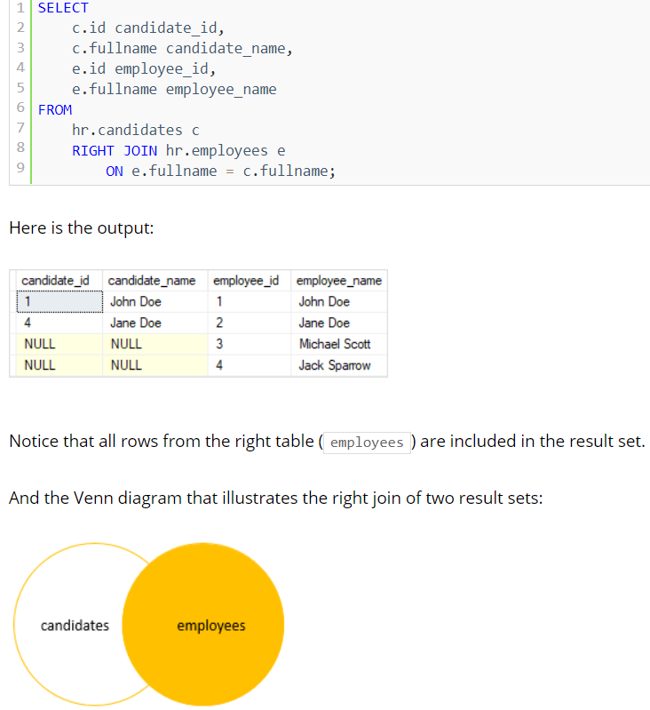

Similarly, you can get rows that are available only in the right table by adding a WHERE clause to the above query as follows:

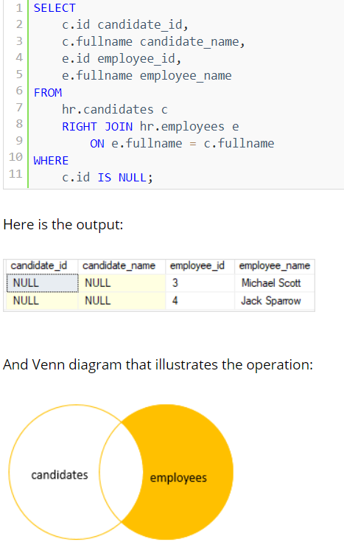

## FULL JOIN

The full outer join or full join returns a result set that contains all rows from both left and right tables, with the matching rows from both sides where available. In case there is no match, the missing side will have NULL values.

The following example shows how to perform a full join between the candidates and employees tables:

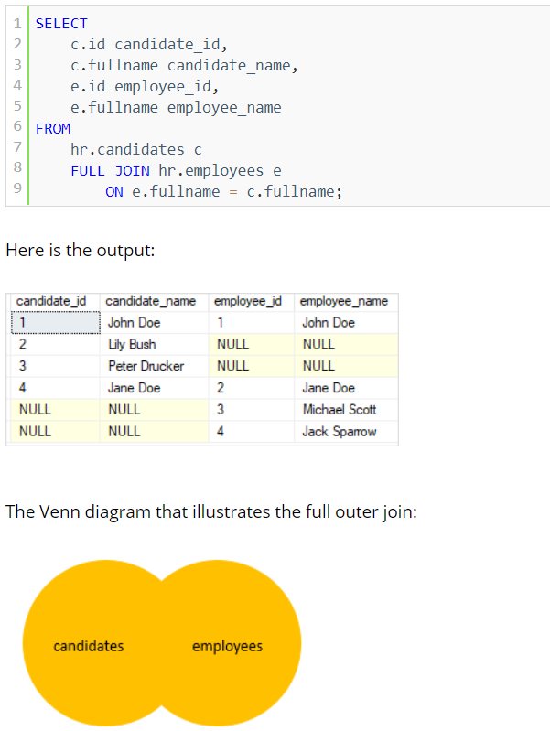

To select rows that exist either left or right table, you exclude rows that are common to both tables by adding a WHERE clause as shown in the following query:

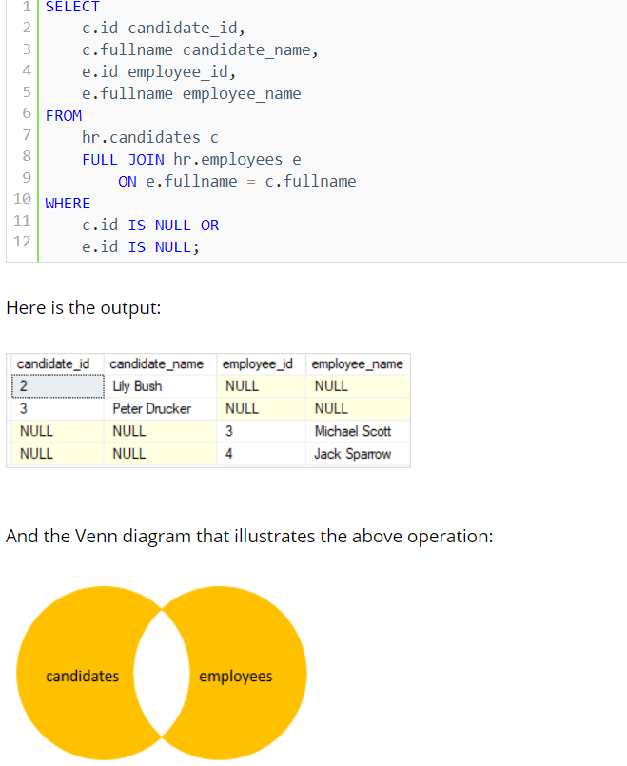

## CROSS JOIN

We can CROSS JOIN to join two or more unrelated tables.

The following illustrates the syntax of SQL Server CROSS JOIN of two tables:

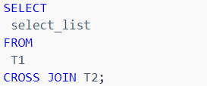

The CROSS JOIN joined every row from the first table (T1) with every row from the second table (T2). In other words, the cross join returns a Cartesian product of rows from both tables.

Unlike the INNER JOIN or LEFT JOIN, the cross join does not establish a relationship between the joined tables.

Suppose the T1 table contains three rows 1, 2, and 3 and the T2 table contains three rows A, B, and C.

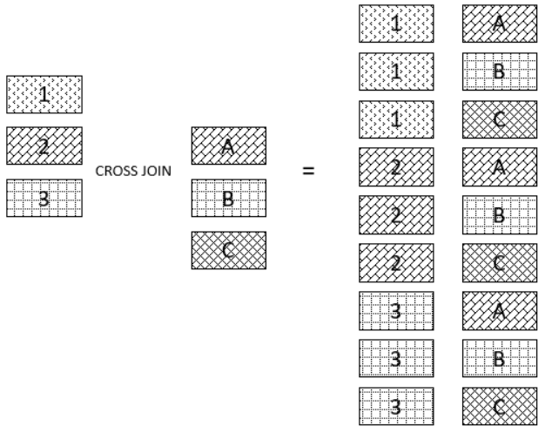

## SELF JOIN

A self-join allows you to join a table to itself. It is useful for querying hierarchical data or comparing rows within the same table.

A self-join uses the inner join or left join clause. Because the query that uses self-join references the same table, the table alias is used to assign different names to the same table within the query.

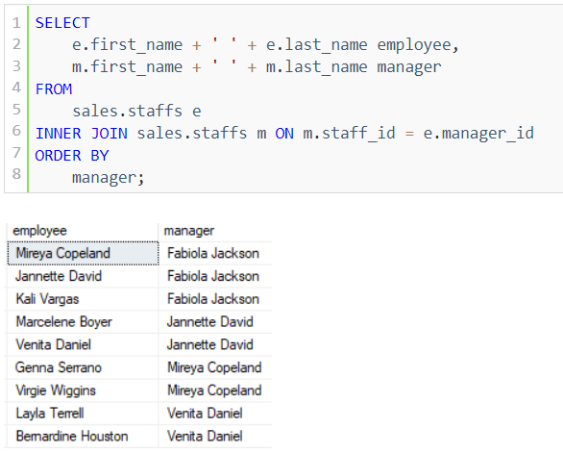

The employee column does not have Fabiola Jackson because of the INNER JOIN effect. If you replace the INNER JOIN clause by the LEFT JOIN clause as shown in the following query, you will get the result set that includes Fabiola Jackson in the employee column:

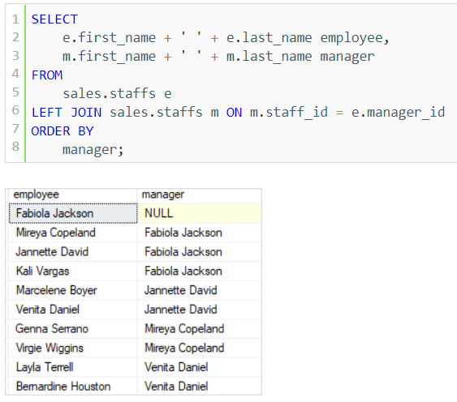

## JOIN OPERATIONS

SQL Server employs three types of join operations:

* Nested Loops joins
* Merge joins
* Hash joins

### NESTED LOOPS JOIN

A nested loops join is particularly effective if the outer input is small and the inner input is preindexed and large. In many small transactions, such as those affecting only a small set of rows, index nested loops joins are superior to both merge joins and hash joins. In large queries, however, nested loops joins are often not the optimal choice.

### MERGE JOINS

If the two join inputs are not small but are sorted on their join column (for example, if they were obtained by scanning sorted indexes), a merge join is the fastest join operation. If both join inputs are large and the two inputs are of similar sizes, a merge join with prior sorting and a hash join offer similar performance. However, hash join operations are often much faster if the two input sizes differ significantly from each other.

The merge join requires both inputs to be sorted on the merge columns, which are defined by the equality (ON) clauses of the join predicate.

### HASH JOINS

Hash joins can efficiently process large, unsorted, nonindexed inputs.

The hash join has two inputs: the build input and probe input. The query optimizer assigns these roles so that the smaller of the two inputs is the build input.

# SUBQUERY

A subquery is a query nested inside another statement such as SELECT, INSERT, UPDATE, or DELETE.

The following statement shows how to use a subquery in the WHERE clause of a SELECT statement to find the sales orders of the customers who locate in New York:

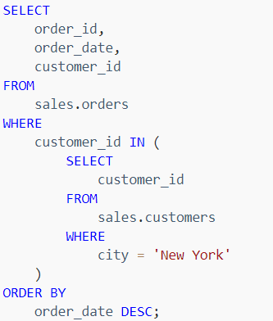

Note that you must always enclose the SELECT query of a subquery in parentheses ().

A subquery is also known as an inner query or inner select while the statement containing the subquery is called an outer select or outer query:

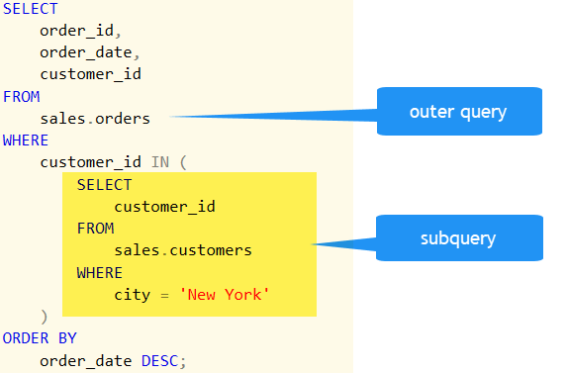

## CORRELATED SUBQUERY

A correlated subquery is a subquery that uses the values of the outer query. In other words, it depends on the outer query for its values. Because of this dependency, a correlated subquery cannot be executed independently as a simple subquery.

Moreover, a correlated subquery is executed repeatedly, once for each row evaluated by the outer query. The correlated subquery is also known as a repeating subquery.

The following example finds the products whose list price is equal to the maximum list price of its category.

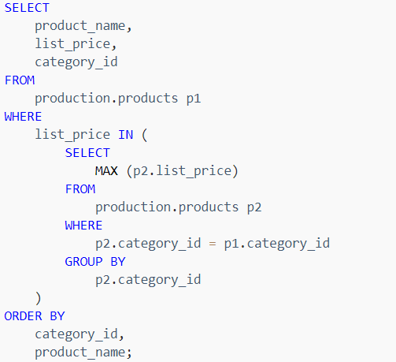

In this example, for each product evaluated by the outer query, the subquery finds the maximum price of all products in its category. If the price of the current product is equal to the maximum price of all products in its category, the product is included in the result set. This process continues for the next product and so on.

As you can see, the correlated subquery is executed once for each product evaluated by the outer query.

## SQL SERVER SUBQUERY TYPES

You can use a subquery in many places:

* In place of an expression
* With IN or NOT IN
* With ANY or ALL
* With EXISTS or NOT EXISTS
* In UPDATE, DELETE, or INSERT statement.

## AS AN EXPRESSION

If a subquery returns a single value, it can be used anywhere an expression is used. In the following example, a subquery is used as a column expression named max_list_price in a SELECT statement.

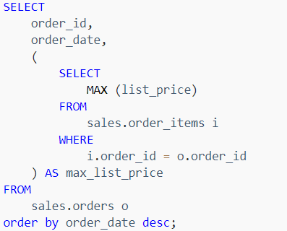

## IN OPERATOR

A subquery which is used with the IN operator returns a set of zero or more values. After the subquery returns values, the outer query makes use of them.

The following query finds the names of all mountain bikes and road bikes products that the Bike Stores sell.

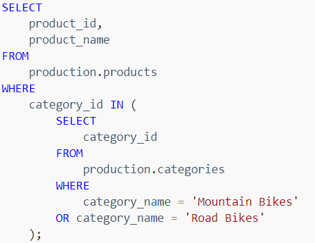

## ANY OPERATOR

The ANY operator is a logical operator that compares a scalar value with a single-column set of values returned by a subquery.

Suppose a subquery returns a list of value v1, v2, … vn. The ANY operator returns TRUE if one of a comparison pair (scalar_expression, vi) evaluates to TRUE; otherwise, it returns FALSE.

For example, the following query finds the products whose list prices are greater than or equal to the maximum list price of any product brand.

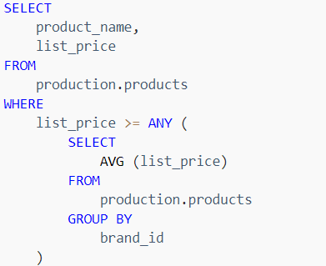

For each brand, the subquery finds the maximum list price. The outer query uses these max prices and determines which individual product’s list price is greater than or equal to any brand’s maximum list price.

## ALL

The SQL Server ALL operator is a logical operator that compares a scalar value with a single-column list of values returned by a subquery.

For example, the following query finds the products whose list prices are bigger than the average list price of products of all brands:

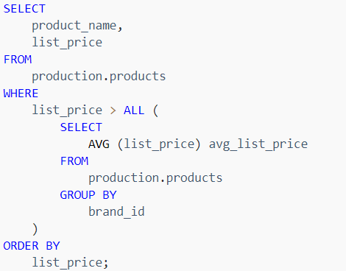

## EXISTS OR NOT EXISTS

The EXISTS operator is a logical operator that allows you to check whether a subquery returns any row. The EXISTS operator returns TRUE if the subquery returns one or more row.

As soon as the subquery returns rows, the EXISTS operator returns TRUE and stop processing immediately. Note that even though the subquery returns a NULL value, the EXISTS operator is evaluated to TRUE.

On the other hand, the NOT EXISTS is opposite to the EXISTS operator. The following query finds the customers who bought products in 2017:

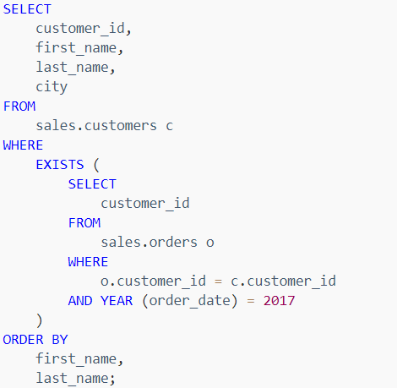

If you use the NOT EXISTS instead of EXISTS, you can find the customers who did not buy any products in 2017.

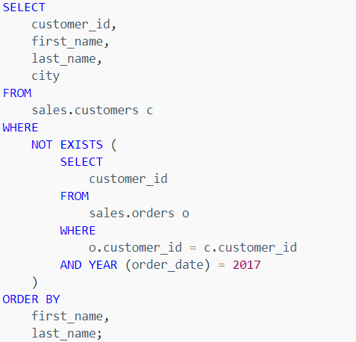

# SET OPERATORS

Set operators in SQL Server are used to carry out operations on two or more result sets.

## UNION

SQL Server UNION is one of the set operations that allows you to combine results of two SELECT statements into a single result set which includes all the rows that belongs to the SELECT statements in the union.

The following illustrates the syntax of the SQL Server UNION:

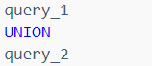

The following are requirements for the queries in the syntax above:

* The number and the order of the columns must be the same in both queries.
* The data types of the corresponding columns must be the same or compatible.

The following Venn diagram illustrates how the result set of the T1 table unions with the result set of the T2 table: illustrates the syntax of the SQL Server UNION:

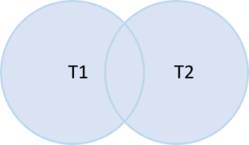

## UNION vs UNION ALL

By default, the UNION operator removes all duplicate rows from the result sets. However, if you want to retain the duplicate rows, you need to specify the ALL keyword explicitly as shown below:

## UNION vs JOIN

The join such as INNER JOIN or LEFT JOIN combines columns from two tables while the UNION combines rows from two queries.

In other words, join appends the result sets horizontally while union appends result set vertically.

The following picture illustrates the main difference between UNION and JOIN:

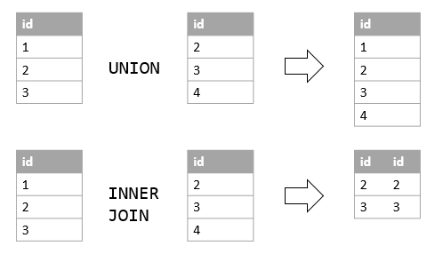

## INTERSECT

The SQL Server INTERSECT combines result sets of two or more queries and returns distinct rows that are output by both queries.

The following illustrates the syntax of the SQL Server INTERSECT:

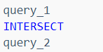

Similar to the UNION operator, the queries in the syntax above must conform to the following rules:

* Both queries must have the same number and order of columns.
* The data type of the corresponding columns must be the same or compatible.

The following picture illustrates the INTERSECT operation:

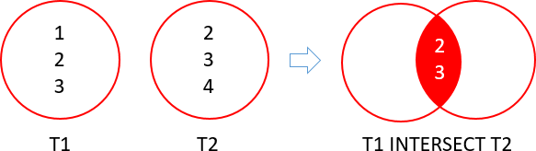

## EXCEPT

The SQL Server EXCEPT compares the result sets of two queries and returns the distinct rows from the first query that are not output by the second query. In other words, the EXCEPT subtracts the result set of a query from another.

The following shows the syntax of the SQL Server EXCEPT:

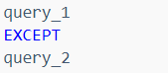

The following are the rules for combining the result sets of two queries in the above syntax:

* The number and order of columns must be the same in both queries.
* The data types of the corresponding columns must be the same or compatible.

The following picture shows the EXCEPT operation of the two result sets T1 and T2:

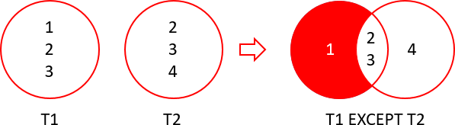

The except of the T1 and T2 returns 1 which is the distinct row from the T1 result set that does not appear in the T2 result set.

## APPLY

# COMMON TABLE EXPRESSION

CTE stands for common table expression. A CTE allows you to define a temporary named result set that available temporarily in the execution scope of a statement such as SELECT, INSERT, UPDATE, DELETE, or MERGE.

We prefer to use common table expressions rather than to use subqueries because common table expressions are more readable. We also use CTE in the queries that contain analytic functions (or window functions)

Below is the syntax

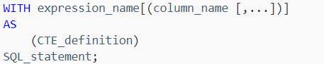

In this syntax:

* First, specify the expression name (expression_name) to which you can refer later in a query.
* Next, specify a list of comma-separated columns after the expression_name. The number of columns must be the same as the number of columns defined in the CTE_definition.
* Then, use the AS keyword after the expression name or column list if the column list is specified.
* After, define a SELECT statement whose result set populates the common table expression.
* Finally, refer to the common table expression in a query (SQL_statement) such as SELECT, INSERT, UPDATE, DELETE, or MERGE.

Example:

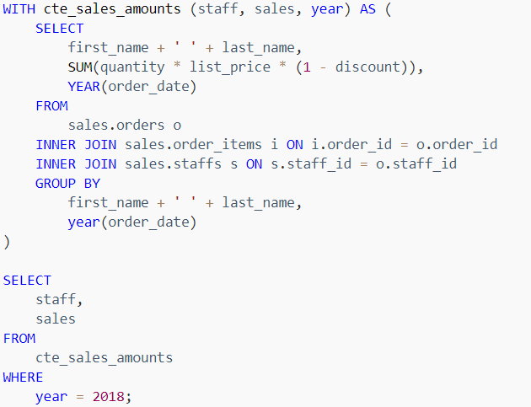

## RECURSIVE CTE

(CTE) is a CTE that references itself. By doing so, the CTE repeatedly executes, returns subsets of data, until it returns the complete result set.

A recursive CTE is useful in querying hierarchical data such as organization charts where one employee reports to a manager or multi-level bill of materials when a product consists of many components, and each component itself also consists of many other components.

The following shows the syntax of a recursive CTE:

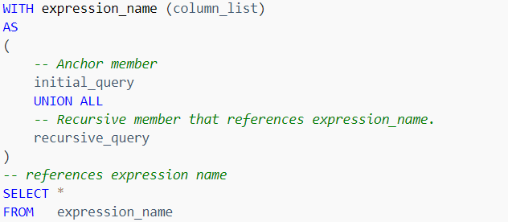

In general, a recursive CTE has three parts:

* An initial query that returns the base result set of the CTE. The initial query is called an anchor member.
* A recursive query that references the common table expression, therefore, it is called the recursive member. The recursive member is union-ed with the anchor member using the UNION ALL operator.
* A termination condition specified in the recursive member that terminates the execution of the recursive member.

The execution order of a recursive CTE is as follows:

* First, execute the anchor member to form the base result set (R0), use this result for the next iteration.
* Second, execute the recursive member with the input result set from the previous iteration (Ri-1) and return a sub-result set (Ri) until the termination condition is met.
* Third, combine all result sets R0, R1, … Rn using UNION ALL operator to produce the final result set.

The following flowchart illustrates the execution of a recursive CTE:

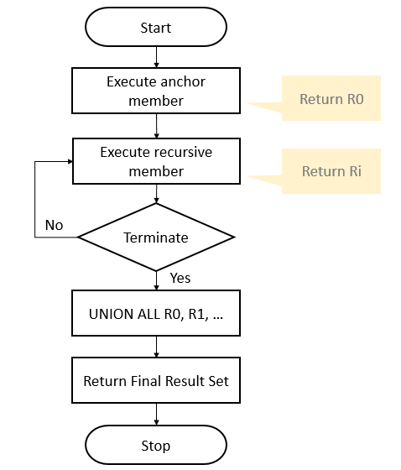

This example uses a recursive CTE to returns weekdays from Monday to Saturday

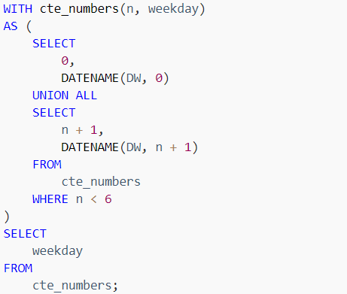

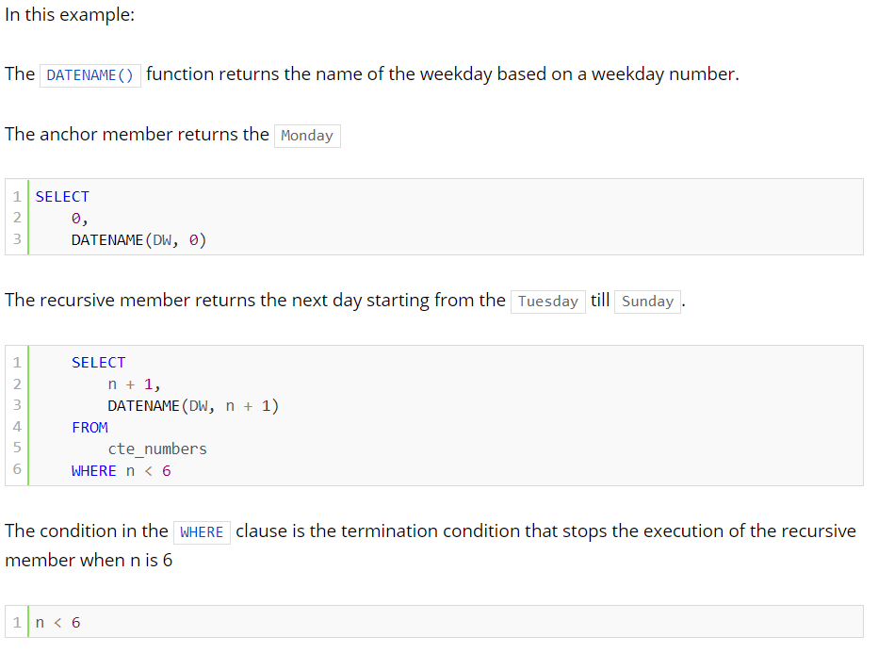

# TABLES

Tables are the primary means of storing data within a database. There are two types of tables:

* User defined tables.
* System tables: Meta data for SQL Instance.

## COMPONENTS OF A TABLE

A table has mainly two components:

* Rows
* Columns

For a table to physically exists, it should have at least one column and zero or more rows.

## NORMALIZATION

Normalization is usually performed for OLTP (OnLine Transaction Processing) databases. All OLTP tables are usually Normalized. Normalization is performed on OLPT databases to improve performance or to cut down on storage. It cut down on storage by removing redundant data/ information. OLPT databases improve transactional performance.

OLAP (Online Analytics Processing) databases on the other hand are mainly used for reporting purposes hence we need data to be returned quickly. Hence, we do denormalization for OLAP databases. OLAP databases improve query performance.

While normalizing a database, we usually go up to 3rd normal form.

* In **First Normal Form** we remove redundant data and create a primary key.
* In **Second Normal Form** we create foreign key that references the associated primary key.
* In **Third Normal Form** we remove the data that do not relies / depend on either of the keys.

## CREATE TABLE

Tables are used to store data in the database. Tables are uniquely named within a database and schema. Each table contains one or more columns. And each column has an associated data type that defines the kind of data it can store e.g., numbers, strings, or temporal data.

The following statement creates a new table named sales.visits to track the customer in-store visits:

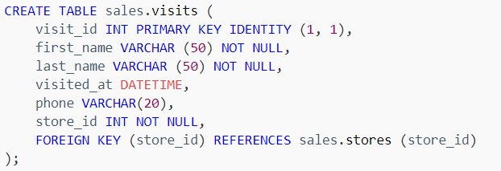

## ALTER TABLE ADD

We can use ALTER TABLE ADD statement to add one or more columns to a table.

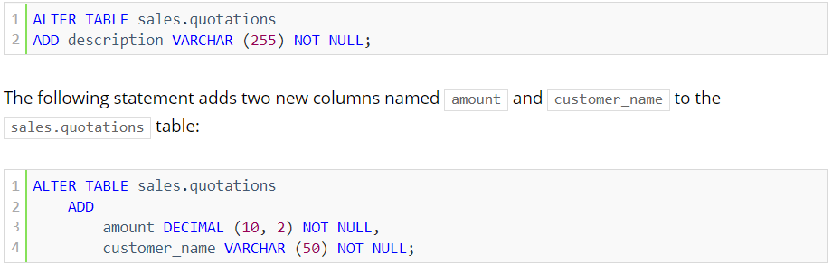

## ALTER TABLE ALTER COLUMN

We can use ALTER TABLE ALTER COLUMN statement to modify a column of a table.

SQL Server allows you to perform the following changes to an existing column of a table:

* Modify the data type
* Change the size
* Add a NOT NULL constraint

When changing the data type of a columns of a table, the new data type must be compatible with the old one, otherwise, you will get a conversion error in case the column has data and it fails to convert.



You can increase the size of the column as follows:



If you want to add the NOT NULL constraint to the column c, you must update NULL to non-null first

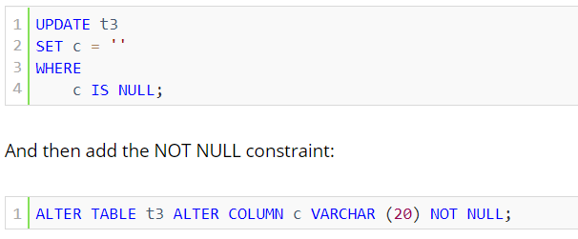

## ALTER TABLE DROP

ALTER TABLE DROP column statement to remove one or more columns from existing table. Sometimes, you need to remove one or more unused or obsolete columns from a table.

If the column that you want to delete has a CHECK constraint, you must delete the constraint first before removing the column. Also, SQL Server does not allow you to delete a column that has a PRIMARY KEY or a FOREIGN KEY constraint.

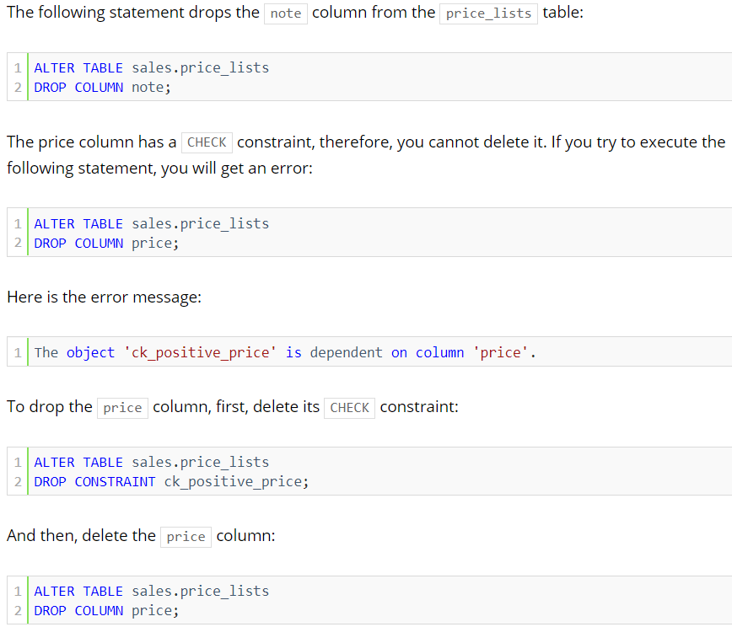

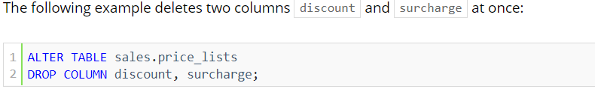

## COMPUTED COLUMNS

SQL Server provides us with a feature called computed columns that allows you to add a new column to a table with the value derived from the values of other columns in the same table.

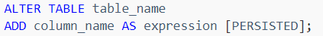

For example, you can add the full_name column to the persons table by using the ALTER TABLE ADD column as follows:

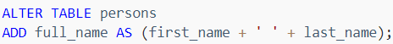

If you examine the persons table, you can see the new full_name column appears in the column list:

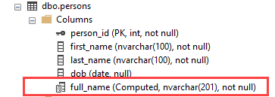

Every time you query data from the persons table, SQL Server computes the value for the full_name column based on the expression first_name + ' ' + last_name and returns the result.

### PERSISTED COMPUTED COLUMNS

Computed columns can be persisted. It means that SQL Server physically stores the data of the computed columns on disk.

When you change data in the table, SQL Server computes the result based on the expression of the computed columns and stores the results in these persisted columns physically. When you query the data from the persisted computed columns, SQL Server just needs to retrieve data without doing any calculation. This avoids calculation overhead with the cost of extra storage.

Note that a computed column is persisted only if its expression is deterministic. It means that for a set of inputs, the expression always returns the same result.

For example, the expression first_name + ' ' + last_name is deterministic. However, the GETDATE() function is a non-deterministic function because it returns a different value on a different day.

This formula returns the age in years based on the date of birth and today:

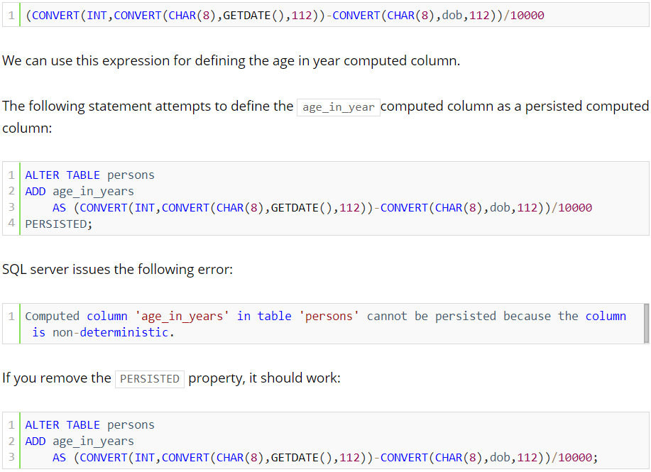

## TEMPORARY TABLES

Temp tables are tables that are not maintained within a database. They are held inside tempdb.

There are two types of temporary tables in SQL Server namely Local and Global temp tables:

**Local temporary tables** (CREATE TABLE #TEMP) are visible only to their creators during the same connection to an instance of SQL Server as when the tables were first created or referenced. Local temporary tables are deleted after the user disconnects from the instance of SQL Server.

**Global temporary tables** (CREATE TABLE ##TEMP) are visible to any user and any connection after they are created and are deleted when all users that are referencing the table disconnect from the instance of SQL Server.

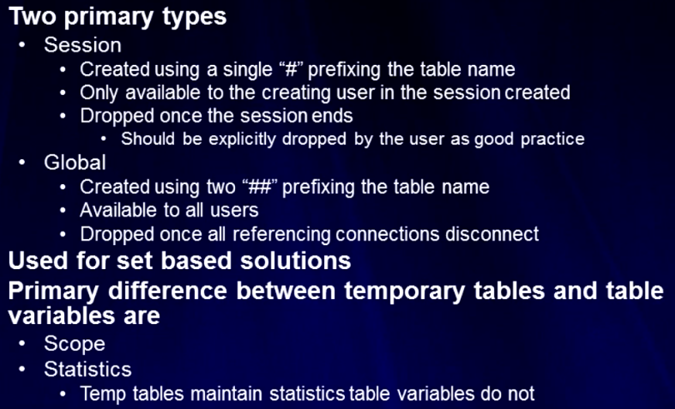

## TABLE VARIABLES

**Table variables** (DECLARE @t TABLE) are visible only to the connection that creates it and are deleted when the batch or stored procedure ends. The main difference between temp table and table variable is scope and statistics.

Table variables scope is limited to execution or within batch which is executing it. Once the batch execution is completed the table variable will loses its scope.

Also, table variables do not maintain statistics whereas temp tables maintain stats. This means when doing multiple modifications on a table, stats are maintained and coz of this reason temp tables outperform table variable.

We cannot access local and global temporary tables in functions (UDFs).

## IDENTITY COLUMN

Creates an identity column in a table. This property is used with the CREATE TABLE and ALTER TABLE Transact-SQL statements. Identity columns can be used for generating key values.

The identity property on a column guarantees the following:

* Each new value is generated based on the current seed & increment.
* Each new value for a transaction is different from other concurrent transactions on the table.

Below is syntax for creating identity column in a table:

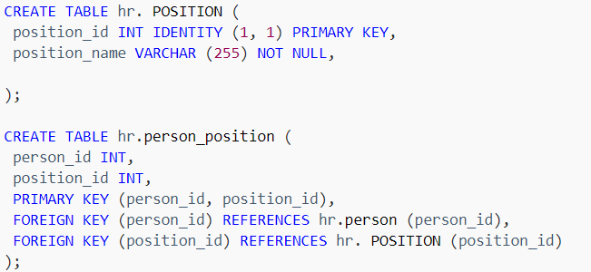

The default value of seed and increment is 1 i.e., (1,1). It means that the first row, which was loaded into the table, will have the value of one, the second row will have the value of 2 and so on.

SQL Server does not reuse the identity values. If you insert a row into the identity column and the insert statement is failed or rolled back, then the identity value is lost and will not be generated again. This results in gaps in the identity column.

## LAST GENERATED IDENTITY

The last generated identity value for an identity column in table can be checked and changed using following

### DBCC CHECKIDENT

Checks the current identity value for the specified table and, if it is needed, changes the identity value. It can also be used to manually set a new current identity value for the identity column.



**NORESEED:** Specifies that the current identity value should not be changed.

**RESEED:** Specifies that the current identity value should be changed.

**new_reseed_value:** Is the new value to use as the current value of the identity column.

You cannot use DBCC CHECKIDENT to perform the following tasks:

* Change the original seed value that was specified for an identity column when the table or view was created.
* Reseed existing rows in a table or view.

To change the original seed value and reseed any existing rows, you must drop the identity column and recreate it specifying the new seed value. When the table contains data, the identity numbers are added to the existing rows with the specified seed and increment values. The order in which the rows are updated is not guaranteed.

DBCC CHECKIDENT with RESEED is used in cases when you have deleted all data from a table containing Identity column and you need to start the identity value from 1. Below syntax can be used for same



### SCOPE_IDENTITY

Returns the identity value for table within the current scope.

SELECT SCOPE_IDENTITY ()

### @@IDENTITY

This is a system function that returns the last-inserted identity value. Return the last identity value generated in any table in the current session.

SELECT @@IDENTITY

### IDENT_SEED

Returns the original seed value that was specified when an identity column in a table or a view was created. Changing the current value of an identity column by using DBCC CHECKIDENT does not change the value returned by this function.

SELECT IDENT_SEED (Address)

### SET IDENTITY_INSERT

Allows explicit values to be inserted into the identity column of a table.

SET IDENTITY_INSERT TABLENAME ON

INSERT INTO TABLENAME (IDENTITY_COL, COL2, COL3, ...)

VALUES (IDENTITY_VALUE, COL2value, COL3value, ...)

SET IDENTITY_INSERT TABLENAME OFF

## SEQUENCE

A sequence is simply a list of numbers, in which their orders are important. For example, the {1,2,3} is a sequence while the {3,2,1} is an entirely different sequence.

In SQL Server, a sequence is a user-defined schema-bound object that generates a sequence of numbers according to a specified specification. A sequence of numeric values can be in ascending or descending order at a defined interval and may cycle if requested.

The following statement uses the CREATE SEQUENCE statement to create a new sequence named item_counter with the type of integer (INT), which starts from 10 and increments by 10:

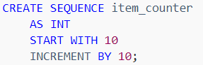

You can view the sequence object under in the Programmability > Sequences as shown in the following picture:

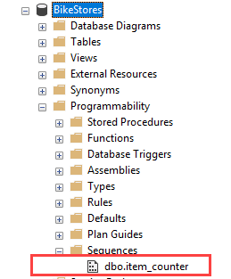

The following statement returns the current value of the item_counter sequence:



Using a sequence object in a single table example:

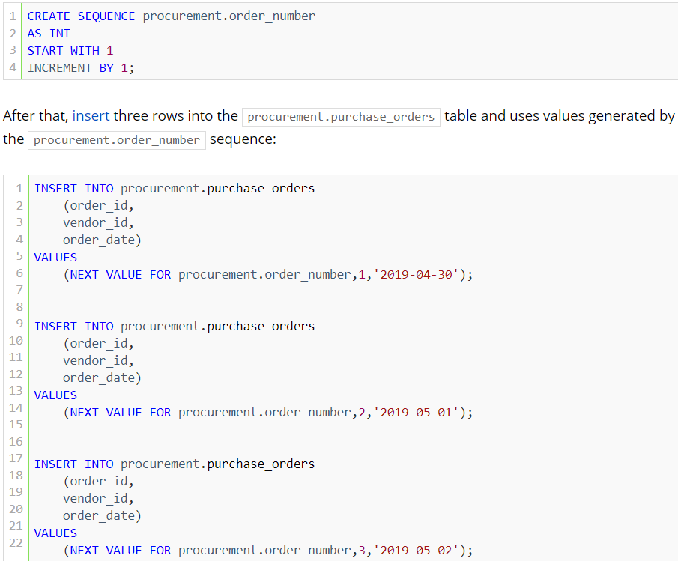

## SEQUENCE VS. IDENTITY COLUMNS

Sequences, different from the identity columns, are not associated with a table. The relationship between the sequence and the table is controlled by applications. In addition, a sequence can be shared across multiple tables.

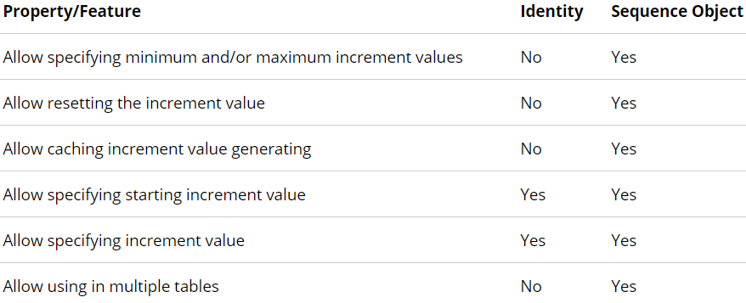

You use a sequence object instead of an identity column in the following cases:

* The application requires a number before inserting values into the table.
* The application requires sharing a sequence of numbers across multiple tables or multiple columns within the same table.
* The application requires to restart the number when a specified value is reached.
* The application requires multiple numbers to be assigned at the same time. Note that you can call the stored procedure sp_sequence_get_range to retrieve several numbers in a sequence at once.
* The application needs to change the specification of the sequence like maximum value.

We can use the view sys.sequences to get the detailed information of sequences.

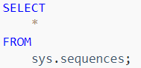

## DROP TABLE

Sometimes, you want to remove a table that is no longer in use. To do this, you use the following DROP TABLE statement:



When SQL Server drops a table, it also deletes all data, triggers, constraints, permissions of that table. Moreover, SQL Server does not explicitly drop the views and stored procedures that reference the dropped table.

SQL Server allows you to remove multiple tables at once using a single DROP TABLE statement.



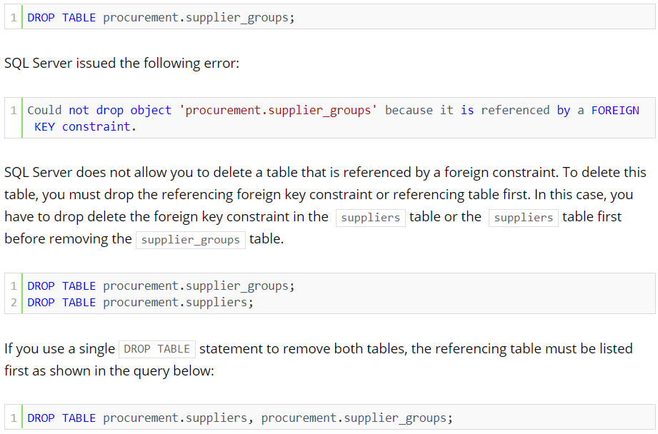

## TRUNCATE

Sometimes, you want to delete all rows from a table. In this case, you typically use the DELETE statement without a WHERE clause.



The TRUNCATE TABLE is similar to the DELETE statement without a WHERE clause. However, the TRUNCATE statement executes faster and uses a fewer system and transaction log resources.

## TRUNCATE TABLE VS DELETE

The TRUNCATE TABLE has the following advantages over the DELETE statement:

* **USE LESS TRANSACTION LOG:** The DELETE statement removes rows one at a time and inserts an entry in the transaction log for each removed row. On the other hand, the TRUNCATE TABLE statement deletes the data by deallocating the data pages used to store the table data and inserts only the page deallocations in the transaction logs.
* **USE FEWER LOCKS:** When the DELETE statement is executed using a row lock, each row in the table is locked for removal. The TRUNCATE TABLE locks the table and pages, not each row.
* **IDENTITY RESET:** If the table to be truncated has an identity column, the counter for that column is reset to the seed value when data is deleted by the TRUNCATE TABLE statement but not the DELETE statement.

## SELECT INTO

SELECT INTO statement creates a new table and inserts rows from the query into it.

The following SELECT INTO statement creates the destination table and copies rows, which satisfy the WHERE condition, from the source table to the destination table:

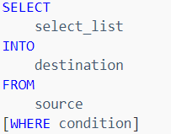

Note that SELECT INTO statement does not copy constraints such as primary key and indexes from the source table to the destination table.

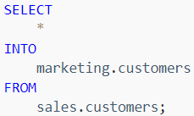

## RENAME TABLE

SQL Server does not have any statement that directly renames a table. However, it does provide you with a stored procedure named sp_rename that allows you to change the name of a table.



Another way to rename a table is to use the function provided by SQL Server Management Studio. The following example illustrates how to rename the product_history table to product_archive.

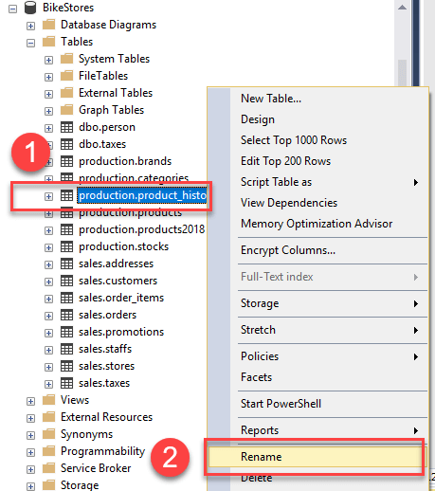

# SYNONYM

In SQL Server, a synonym is an alias or alternative name for a database object such as a table, view, stored procedure, user-defined function, and sequence. A synonym provides you with many benefits if you use it properly.

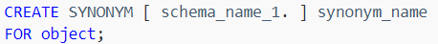

Note that the object for which you create the synonym does not have to exist at the time the synonym is created.

The following example uses the CREATE SYNONYM statement to create a synonym for the sales.orders table:



To list all synonyms of the current database, you query from the sys.synonyms catalog view as shown in the following query:

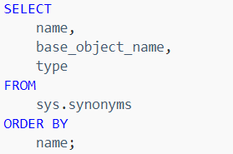

To remove a synonym, you use the DROP SYNONYM statement with the following syntax:



# CONSTRAINTS

We can create following constrains on columns of table(s) in SQL Server.

## PRIMARY KEY

A table typically has a column or combination of columns that contain values that uniquely identify each row in the table. This column, or columns, is called the primary key (PK) of the table and enforces the entity integrity of the table. Primary key does not allow NULL values.

When you specify a primary key constraint for a table, the Database Engine enforces data uniqueness by automatically creating a unique index for the primary key columns. If a primary key constraint is defined on more than one column, values may be duplicated within one column, but each combination of values from all the columns in the primary key constraint definition must be unique.

* A table can contain only one primary key constraint.
* All columns defined within a primary key constraint must be defined as not null. If nullability is not specified, all columns participating in a primary key constraint have their nullability set to not null.
* A primary key cannot exceed 16 columns and a total key length of 900 bytes.
* If clustered or no clustered is not specified for a primary key constraint, clustered is used if there no clustered index on the table.

## FOREIGN KEY

A foreign key (FK) is a column or combination of columns that is used to establish and enforce a link between the data in two tables to control the data that can be stored in the foreign key table. In a foreign key reference, a link is created between two tables when the column or columns that hold the primary key value for one table are referenced by the column or columns in another table. This column becomes a foreign key in the second table.

Unlike primary key constraints, creating a foreign key constraint does not automatically create a corresponding index. However, manually creating an index on a foreign key is often useful.

Although the main purpose of a foreign key constraint is to control the data that can be stored in the foreign key table, it also controls changes to data in the primary key table.

The constraint enforces referential integrity by guaranteeing that changes cannot be made to data in the primary key table if those changes invalidate the link to data in the foreign key table. If an attempt is made to delete the row in a primary key table or to change a primary key value, the action will fail when the deleted or changed primary key value corresponds to a value in the foreign key constraint of another table. To successfully change or delete a row in a foreign key constraint, you must first either delete the foreign key data in the foreign key table or change the foreign key data in the foreign key table, which links the foreign key to different primary key data.

By using cascading referential integrity constraints, you can define the actions that the Database Engine takes when a user tries to delete or update a key to which existing foreign keys point. The following cascading actions can be defined.

* **NOACTION**The Database Engine raises an error and the delete or update action on the row in the parent table is rolled back.
* **CASCADE**Corresponding rows are updated or deleted in the referencing table when that row is updated or deleted in the parent table. ON DELETE CASCADE cannot be specified for a table that has an INSTEAD OF DELETE trigger. ON UPDATE CASCADE cannot be specified for tables that have INSTEAD OF UPDATE triggers.
* **SETNULL**All the values that make up the foreign key are set to NULL when the corresponding row in the parent table is updated or deleted. For this constraint to execute, the foreign key columns must be nullable. Cannot be specified for tables that have INSTEAD OF UPDATE triggers.
* **SETDEFAULT**  
  All the values that make up the foreign key are set to their default values if the corresponding row in the parent table is updated or deleted. For this constraint to execute, all foreign key columns must have default definitions. If a column is nullable, and there is no explicit default value set, NULL becomes the implicit default value of the column. Cannot be specified for tables that have INSTEAD OF UPDATE triggers.

## DEFAULT CONSTARINT

The DEFAULT constraint is used to provide a default value for a column. The default value will be added to all new records IF no other value is specified for that particular column.

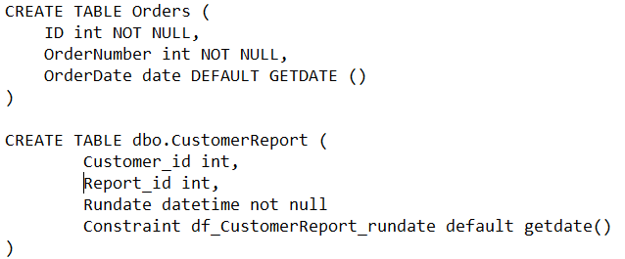



## CHECK CONSTRAINT

Check constraint in a table is created to specify the data values that are acceptable in one or more columns.

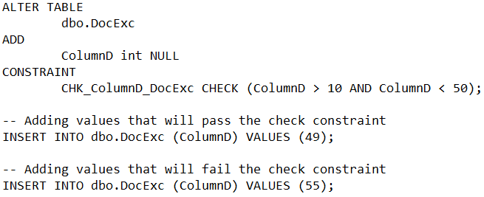

## UNIQUE KEY CONSTRAINT

Unique key constraint is created in a table to ensure no duplicate values are entered in specific columns that do not participate in a primary key. Creating a unique constraint automatically creates a corresponding unique index.

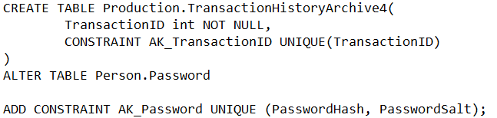

Unique key allows one single NULL value.

# CURSOR

Cursors provide a mechanism by which one can work with one row at a time from a result set.

Cursors extend result processing by:

* Allowing positioning at specific rows of the result set.
* Retrieving one row or block of rows from the current position in the result set.
* Supporting data modifications to the rows at the current position in the result set.

In some scenarios, if there is a primary key on a table, a WHILE loop can be used instead of a cursor, without incurring in the overhead of a cursor.

## FORWARD-ONLY

A forward-only cursor is specified as FORWARD_ONLY and READ_ONLY and does not support scrolling. These are also called firehose cursors and support only fetching the rows serially from the start to the end of the cursor. The rows are not retrieved from the database until they are fetched. The effects of all INSERT, UPDATE, and DELETE statements made by the current user or committed by other users that affect rows in the result set are visible as the rows are fetched from the cursor.

## STATIC

The complete result set of a static cursor is built in tempdb when the cursor is opened. A static cursor always displays the result set as it was when the cursor was opened. Static cursors detect few or no changes, but consume relatively few resources while scrolling.

## DYNAMIC

Dynamic cursors reflect all changes made to the rows in their result set when scrolling through the cursor.

## CURSOR PROCESS

Transact-SQL cursors and API cursors have different syntax, but the following general process is used with all SQL Server cursors:

1. **DECLARE CURSOR:** Associate a cursor with the result set of a Transact-SQL statement, and define characteristics of the cursor, such as whether the rows in the cursor can be updated.
2. **OPEN CURSOR:** Execute the Transact-SQL statement to populate the cursor.
3. **FETCH THE ROWS:** Retrieve the rows in the cursor you want to see. The operation to retrieve one row or one block of rows from a cursor is called a fetch. Performing a series of fetches to retrieve rows in either a forward or backward direction is called scrolling.

Optionally, perform modification operations (update or delete) on the row at the current position in the cursor.

1. **CLOSE THE CURSOR:** Close the cursor.
2. **DEALLOCATE THE CURSOR:** The cursor definition and data can be removed by deallocating the cursor.

# INDEXES IN SQL

Data is arranged by SQL Server in the form of *extents* and *pages*. Each extent is of size 64 KB, having 8 pages of 8KB sizes. An extent may have data from multiple or same table, but each page holds data from a single table only. Every row will be stored on a 8KB page unless it contains BLOB (binary large objects) like varchar(max) or varbinary(max).

## HEAP

A table is nothing but a collection of record sets, by default rows are stored in the form of heap.

* Rows are stored in no particular order in a heap.
* Table scan is performed when a query is performed against the table stored as heap.
* Tables stored as heap does not have cluster index.
* Heap can contain one or more non clustered index.

### WHEN TO USE A HEAP

If a table is a heap and does not have any nonclustered indexes, then the entire table must be examined (a table scan) to find any row.

This can be acceptable when the table is tiny, such as a list of the 12 regional offices of a company.

### WHEN NOT TO USE A HEAP

Do not use a heap when the data is frequently returned in a sorted order. A clustered index on the sorting column could avoid the sorting operation.

Do not use a heap when the data is frequently grouped together. Data must be sorted before it is grouped, and a clustered index on the sorting column could avoid the sorting operation.

Do not use a heap when ranges of data are frequently queried from the table. A clustered index on the range column will avoid sorting the entire heap.

Do not use a heap when there are no nonclustered indexes and the table is large. In a heap, all rows of the heap must be read to find any row.

### MANAGING HEAPS

To create a heap, create a table without a clustered index. If a table already has a clustered index, drop the clustered index to return the table to a heap.

To remove a heap, create a clustered index on the heap.

To rebuild a heap to reclaim wasted space, create a clustered index on the heap, and then drop that clustered index.

## INDEX

If a table contains a clustered index then it called a clustered table.

ANSCI standards do not recognize indexes, usually index is not required for any database. But they are usually created for improving transactions and queries performance.

Heaps seem a great option when the motive is simply storing data. Indexes are arranged in the form of a B-Tree where the leaf node holds the data or a pointer to the data.

But everything comes at a cost; the price we pay for having an index on the table is, each time there is an Insert/Update/Delete, SQL Server updates the active indexes on the table where these DML are operated.

Hence simply creating indexes for the sake of better data retrieval will not serve the purpose. If there are 20 indexes on a table, each time a DML is done on the table, all these 20 indexes shall be updated so that they can uniquely figure out the location of the record.

We have usually below index types:

* Cluster index
* Non cluster index
* Filtered index (using where condition). We can create on non-clustered filter index.
* Covering index (only non-cluster index can be covering index). All columns associated with a query are contained in the non – clustered index. Its created using INCLUDE statement.

## CONSIDERATIONS FOR CREATING INDEX

Below are some considerations we should keep in mind before creating an index:

1. Considering average use or average work load while creating index.
2. Cluster and non-cluster index are transactional in nature. Keep in mind when indexes are created on an oltp database they provide improved performance but they need to be maintained if the key columns are affected.
3. Whether the indexes should be created in ascending or descending order.
4. Selectivity – number of rows selected when compared to total rows. The more selective the better.
5. Density - Lack of uniqueness or multiple duplicate values
6. Dept – levels within an index.
7. Data types: Numeric data types are most efficient. Date type are more efficient compared to datetime. Bit data type is also efficient. String data types are not very efficient.

## CLUSTER

A clustered index defines how table rows will be ordered based on the index key. The indexed values are sorted either in ascending or descending order hence a table can have only one clustered index.

* Uses a balanced tree (B -Tree) algorithm.
* Excellent for searching exact values or range of values.

Also remember, a unique clustered index will be created on a table by default the moment a primary key is created on the table (if the table does not have a cluster index already created. If cluster index is already created then a unique non-clustered index is created).

Cluster index have 3 levels:

1. Root level (points to the intermediate level and gives the information about the order in which the data will be available).
2. Intermediate level (consist all of all the key columns).
3. Leaf level contains the actual table data for a corresponding key column. Rows are ordered as per the key column.
4. A table can have only one cluster index as it specifies the physical ordering of the table data bases on the key column(s).
5. A cluster index need not be unique but it’s a good practise to make it unique as it will give better performance. And by using unique keyword with cluster we can make it unique.

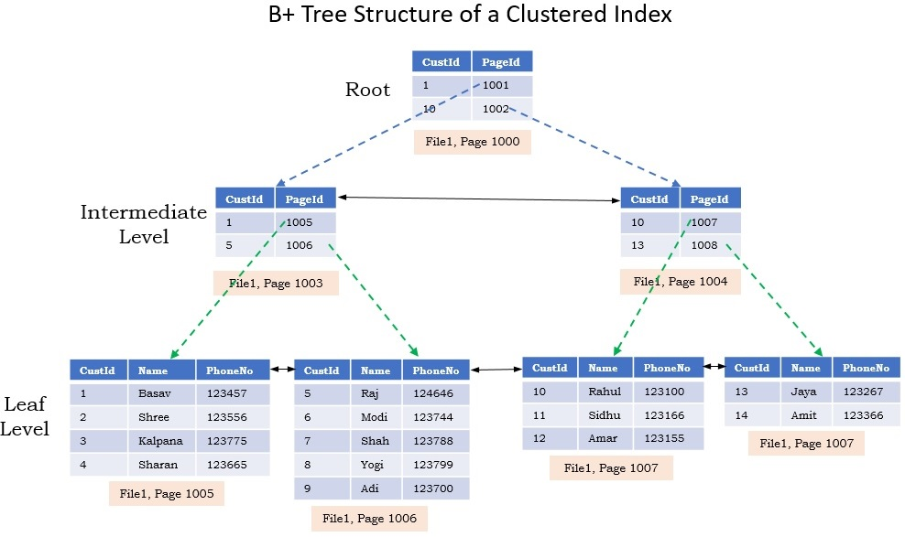

## NONCLUSTER

Non cluster index does not enforce ordering of the data pages. It sits logically on top of a cluster index or above of a heap.

The leaf level data pages of the non-cluster index will point to the leaf level data pages of the heap or the cluster index.

It uses B-Tree algorithm:

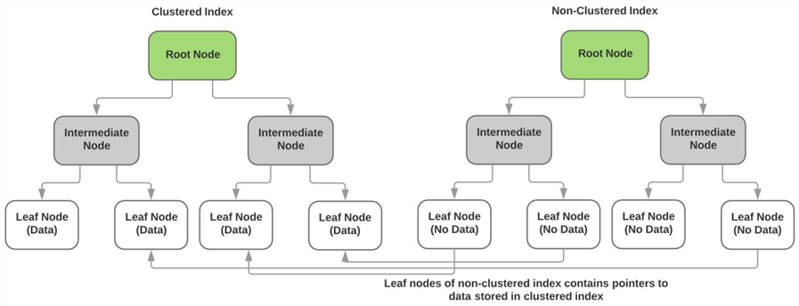

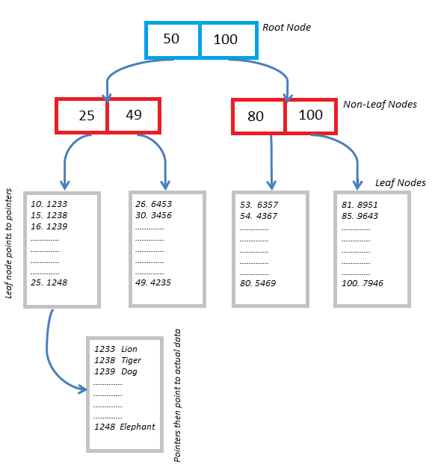

Unlike a clustered indexed, the leaf nodes of a nonclustered index contain only the values from the indexed columns and row locators that point to the actual data rows, rather than contain the data rows themselves. This means that the query engine must take an additional step in order to locate the actual data.

A row locator’s structure depends on whether it points to a clustered table or to a heap. If referencing a clustered table, the row locator points to the clustered index, using the value from the clustered index to navigate to the correct data row. If referencing a heap, the row locator points to the actual data row.

When a non-clustered index uses the heap, the leaf node (or the pointer) is a physical location of the data. When it uses a clustered index, the leaf node (or the pointer) is the clustered index key value and this key value in turn points to the actual data.

We can create more than one nonclustered index per table or view.

In addition to being able to create multiple nonclustered indexes on a table or view, you can also add *included columns* to your index. This means that you can store at the leaf level not only the values from the indexed column, but also the values from non-indexed columns. This strategy allows you to get around some of the limitations on indexes.

## **UNIQUE** INDEX

A unique index ensures that the index key contains no duplicate values and therefore every row in the table or view is in some way unique. Uniqueness can be a property of both clustered and nonclustered indexes.

## COLUMNSTORE

A columnstore is data that's logically organized as a table with rows and columns, and physically stored in a column-wise data format.

An in-memory Columnstore index stores and manages data by using column-based data storage and column-based query processing. Columnstore indexes work well for data warehousing workloads that primarily perform bulk loads and read-only queries.

### COLUMNSTORE

A columnstore is data that's logically organized as a table with rows and columns, and physically stored in a column-wise data format.

### ROWSTORE

A rowstore is data that's logically organized as a table with rows and columns, and physically stored in a row-wise data format. This format is the traditional way to store relational table data. In SQL Server, rowstore refers to a table where the underlying data storage format is a heap, a clustered index, or a memory-optimized table.

### ROWGROUP

A rowgroup is a group of rows that are compressed into columnstore format at the same time. A rowgroup usually contains the maximum number of rows per rowgroup, which is 1,048,576 rows.

### COLUMN SEGMENT

A column segment is a column of data from within the rowgroup.

* Each rowgroup contains one column segment for every column in the table.
* Each column segment is compressed together and stored on physical media.

### CLUSTERED COLUMNSTORE INDEX

A clustered columnstore index is the physical storage for the entire table.

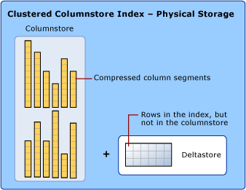

To reduce fragmentation of the column segments and improve performance, the columnstore index might store some data temporarily into a clustered index called a deltastore and a btree list of IDs for deleted rows.

### DELTA ROWGROUP

A delta rowgroup is a clustered index that's used only with columnstore indexes. It improves columnstore compression and performance by storing rows until the number of rows reaches a threshold and are then moved into the columnstore.

When a delta rowgroup reaches the maximum number of rows, it becomes closed. A tuple-mover process checks for closed row groups. If the process finds a closed rowgroup, it compresses the rowgroup and stores it into the columnstore.

### DELTASTORE

A columnstore index can have more than one delta rowgroup. All of the delta rowgroups are collectively called the deltastore.

During a large bulk load, most of the rows go directly to the columnstore without passing through the deltastore. Some rows at the end of the bulk load might be too few in number to meet the minimum size of a rowgroup, which is 102,400 rows. As a result, the final rows go to the deltastore instead of the columnstore. For small bulk loads with less than 102,400 rows, all of the rows go directly to the deltastore.

### NONCLUSTERED COLUMNSTORE INDEX

A nonclustered columnstore index and a clustered columnstore index function the same. The difference is that a nonclustered index is a secondary index that's created on a rowstore table, but a clustered columnstore index is the primary storage for the entire table.

### RECOMMENDED USE CASES

A columnstore index can provide a very high level of data compression, typically by 10 times, to significantly reduce your data warehouse storage cost.

* Columnstore indexes are the preferred data storage format for data warehousing and analytics workloads.
* Use a clustered columnstore index to store fact tables and large dimension tables for data warehousing workloads.
* Use a nonclustered columnstore index to perform analysis in real time on an OLTP workload.

### CHOOSING BETWEEN A ROWSTORE INDEX AND A COLUMNSTORE INDEX

Rowstore indexes perform best on queries that seek into the data, when searching for a particular value, or for queries on a small range of values. Use rowstore indexes with transactional workloads because they tend to require mostly table seeks instead of table scans.

Columnstore indexes give high performance gains for analytic queries that scan large amounts of data, especially on large tables. Use columnstore indexes on data warehousing and analytics workloads, especially on fact tables, because they tend to require full table scans rather than table seeks.

## INCLUDED COLUMN (COVERING INDEX)

A nonclustered index that is extended to include nonkey columns in addition to the key columns. The included columns are not included in the key columns but they are maintained in the leaf level.

## FILTER INDEX

An optimized nonclustered index, especially suited to cover queries that select from a well-defined subset of data. It uses a filter predicate to index a portion of rows in the table. A well-designed filtered index can improve query performance, reduce index maintenance costs, and reduce index storage costs compared with full-table indexes.

# VIEW

A view is a virtual table whose contents are defined by a query which fetches data from 1 or more tables.

* Unless indexed, a view does not exist as a stored set of data values in a database.
* The rows and columns of data come from tables referenced in the query defining the view and are produced dynamically when the view is referenced.
* It can only return single result.
* Cannot use temp table.
* We cannot do error handling in view.
* Views can work with almost all the database objects except SP.

A view acts as a filter on the underlying tables referenced in the view. The query that defines the view can be from one or more tables or from other views in the current or other databases.

## ADVANTAGES OF VIEWS

* **Security**: Each user can be given permission to access the database only through a small set of views that contain the specific data the user is authorized to see, thus restricting the user's access to stored data.
* **Query Simplicity**: A view can draw data from several different tables and present it as a single table, turning multi-table queries into single-table queries against the view.
* **Structural simplicity**: Views can give a user a "personalized" view of the database structure, presenting the database as a set of virtual tables that make sense for that user.
* **Consistency:** A view can present a consistent, unchanged image of the structure of the database, even if the underlying source tables are split, restructured, or renamed.

## LIMITATIONS OF VIEWS

* We cannot pass parameters to view. Table valued functions can be used as a replacement for parameterised views.
* Rules and Defaults cannot be associated with views
* The ORDER by clause is invalid in views unless TOP or FOR XML is also specified in the query.
* View cannot be created on TEMP TABLES.
* Performance issues if VIEW is based on complex join queries or data is spread cross servers.

ORDER BY clause is invalid in views, subqueries, inline functions, derived tables and CTE unless TOP or FOR XML is also specified.

## TYPES OF VIEWS

**User Defined Views:** User-defined views are created by a user depending on his requirements.

**Indexed Views:** An indexed view is a view that has been materialized. This means the view definition has been computed and the resulting data stored just like a table. You index a view by creating a unique clustered index on it. Indexed views can dramatically improve the performance of some types of queries. Indexed views work best for queries that aggregate many rows. They are not well-suited for underlying data sets that are frequently updated. A unique clustered index can be created on a view by using WITH SCHEMABINDING keyword.

**Partitioned Views:** A partitioned view is a view defined by a UNION ALL of member tables. A partitioned view joins horizontally partitioned data from a set of member tables across one or more servers. This makes the data appear as if from one table. A view that joins member tables on the same instance of SQL Server is a local partitioned view. A view that joins member tables across instance of SQL Server is a distributed partitioned view.

**System Views:** You can use system views to return information about the instance of SQL Server or the objects defined in the instance. For example, you can query the sys. databases catalogue view to return information about the user-defined databases available in the instance.

## MODIFY DATA THROUGH A VIEW

We can perform INSERT, UPDATE and DELETE operations on the underlying table data via VIEWS. If view is based on multiple base tables then the operations may or not correctly update the base table. To avoid any incorrect modifications to the base table(s), INSTEAD OF triggers are used.

## VIEW SYNTAX

Below syntax can be used to create view

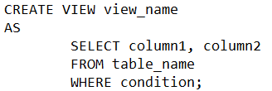

Syntax for Partitioned view:

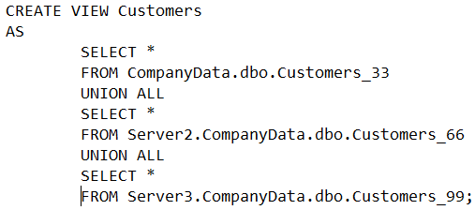

# FUNCTION

Functions accept zero or multiple parameters, performs an action and return the result of that action as a value. The returned value can either be a scalar value or a result set.

Scalar function is referenced in SELECT clause whereas table valued function is referenced in from clause. We also have to provide schema name with function name to access the function.

We cannot modify data within database using functions as we can do with views and stored procedures. Functions can be created using T – SQL or CLR.

Below are some of the features of functions:

* Functions are database object in SQL server.
* Table valued function is also called as parameterised view.
* By using functions, we can do complex arithmetical operations and programming.
* Supports only reading data. We cannot use function to Insert/Update/Delete records in the database table(s).
* We can call scalar function in SELECT and table valued function in FROM clause.
* We cannot use transactions inside a function.
* We cannot perform error handling within a function.
* Cursors and variables can be used inside functions.
* We cannot use temp tables inside a function.

## WINDOWED FUCNTION

A window function performs a calculation across a set of table rows that are somehow related to the current row. But unlike regular aggregate functions, use of a window function does not cause rows to become grouped into a single output row — the rows retain their separate identities. Behind the scenes, the window function is able to access more than just the current row of the query result.

The most practical example of this is a Running Total, Rank (), Row_Number etc.

Windowed functions can only appear in the SELECT or ORDER BY clauses since they are calculated when SELECT is evaluated by SQL Server.

## TYPE OF FUNCTIONS

**SYSTEM FUNCTIONS:** SQL Server provides many system functions that you can use to perform a variety of operations. They cannot be modified.

@@ERROR, @@ROWCOUNT, @@IDENTITY, ERROR_MESSAGE, ERROR_LINE, ERROR_STATE, ISNULL, ISNUNERIC etc are few examples of system functions.

**SCALAR FUNCTION:** User-defined scalar functions return a single data value of the type defined in the RETURNS clause.

**INLINE TABLE-VALUED FUNCTION:** It returns a table variable as a result of actions perform by function. The value of table variable should be derived from a single SELECT statement.

**MULTI STATEMENT TABLE-VALUED FUNCTION:** Multi-statement table-valued function returns a table variable as a result of actions perform by function. We define the structure of the table variable to be returned by the function.

## NON-DETERMINISTIC & DETERMINISTIC FUNCTIONS

**DETERMINISTIC:** Deterministic functions always return the same result any time they are called with a specific set of input values and given the same state of the database. E.g. AVG, SUM

**NON-DETERMINISTIC:** Nondeterministic functions may return different results each time they are called with a specific set of input values even if the database state that they access remains the same. E.g. GETDATE ()

A clustered index cannot be created on a view if the view references any nondeterministic functions

## ADVANTAGES OF FUNCTIONS

* **They allow modular programming:** You can create the function once, store it in the database, and call it any number of times in your program. User-defined functions can be modified independently of the program source code.
* **They allow faster execution:** Similar to stored procedures, Transact-SQL user-defined functions reduce the compilation cost of Transact-SQL code by caching the plans and reusing them for repeated executions. This means the user-defined function does not need to be reparsed and reoptimized with each use resulting in much faster execution times.
* **They can reduce network traffic:** An operation that filters data based on some complex constraint that cannot be expressed in a single scalar expression can be expressed as a function. The function can then be invoked in the WHERE clause to reduce the number or rows sent to the client.

## FUNCTION SYNTAX

Below syntax can be used to create scalar function:

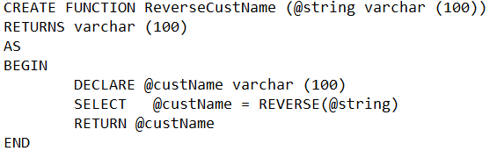

Below is the syntax for inline table valued function

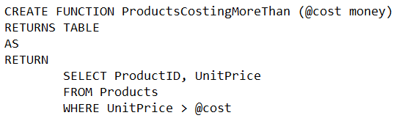

Below syntax can be used to create multi statement table valued function

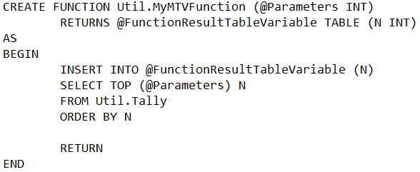

## AGGREGATE FUNCTIONS

An aggregate function performs a calculation on a set of values and returns a single value. Except for COUNT, aggregate functions ignore null values. Aggregate functions are often used with the GROUP BY clause of the SELECT statement. They can also be used in SELECT, HAVING and ORDR BY clause.

**AVG:** This function returns the average of the values in a group. It ignores null values.

**COUNT:** This function returns the number of items found in a group

**MAX:** Returns the maximum value in the expression.

**MIN:** Returns the minimum value in the expression.

**SUM:** Returns the sum of all the values, or only the DISTINCT values, in the expression. SUM can be used with numeric columns only. Null values are ignored.

**STDEV:** Returns the statistical standard deviation of all values in the specified expression.

**STDEVP:** Returns the statistical standard deviation for the population for all values in the specified expression.

**VAR:** Returns the statistical variance of all values in the specified expression

**VARP:** Returns the statistical variance for the population for all values in the specified expression.

## ANALYTIC FUNCTIONS

**FIRST_VALUE:** Returns the first value in an ordered set of values

FIRST_VALUE (scalar_expression) OVER (partition_by_clause order_by_clause)

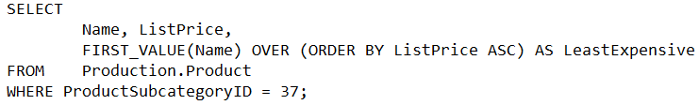

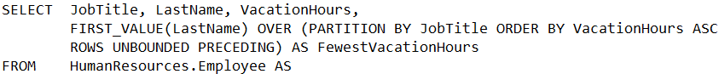

**LAST_VALUE:** Returns the last value in an ordered set of values

LAST_VALUE (scalar_expression) OVER (partition_by_clause order_by_clause)



**LAG:** Accesses data from a previous row in the same result set without the use of a self-join starting with SQL Server 2012. LAG provides access to a row at a given physical offset that comes before the current row. Use this analytic function in a SELECT statement to compare values in the current row with values in a previous row.

LAG (scalar_expression, OFFSER, DEFAULT) OVER (partition_by_clause order_by_clause)

**scalar_expression:** The value to be returned based on the specified offset. It is an expression of any type that returns a single (scalar) value. scalar_expression cannot be an analytic function.

**Offset:** The number of rows back from the current row from which to obtain a value. If not specified, the default is 1. Offset can be a column, subquery, or other expression that evaluates to a positive integer or can be implicitly converted to bigint. offset cannot be a negative value or an analytic function.

**Default:** The value to return when scalar_expression at offset is NULL. If a default value is not specified, NULL is returned. default can be a column, subquery, or other expression, but it cannot be an analytic function. default must be type-compatible with scalar_expression.



**LEAD:** Accesses data from a subsequent row in the same result set without the use of a self-join starting with SQL Server 2012. LEAD provides access to a row at a given physical offset that follows the current row. Use this analytic function in a SELECT statement to compare values in the current row with values in a following row.

LEAD (scalar_expression, OFFSER, DEFAULT) OVER (partition_by_clause order_by_clause)



**PERCENT_RANK:** Calculates the relative rank of a row within a group of rows in SQL Server 2017. Use PERCENT_RANK to evaluate the relative standing of a value within a query result set or partition.

The range of values returned by PERCENT_RANK is greater than 0 and less than or equal to 1. The first row in any set has a PERCENT_RANK of 0. NULL values are included by default and are treated as the lowest possible values.

PERCENT_RANK () OVER ([partition_by_clause] order_by_clause)

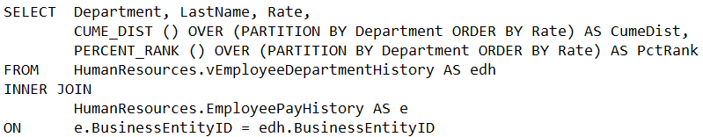

The PERCENT_RANK function computes the rank of the employee's salary within a department as a percentage. The PARTITION BY clause is specified to partition the rows in the result set by department. The ORDER BY clause in the OVER clause orders the rows in each partition. The ORDER BY clause in the SELECT statement sorts the rows in the whole result set.

## CONVERSION FUNCTIONS

**CAST:** This function converts an expression of one data type to another.

SELECT 9.5 AS Original, CAST (9.5 AS INT) AS int, CAST (9.5 AS DECIMAL (6,4)) AS decimal;

Original int decimal

9.5 9 9.5000

**CONVERT:** This function converts an expression of one data type to another.

SELECT 9.5 AS Original, CONVERT (int, 9.5) AS int, CONVERT (decimal (6,4), 9.5) AS decimal;

Original int decimal

9.5 9 9.5000

**PARSE:** Returns the result of an expression, translated to the requested data type in SQL Server. If a null constant is passed, an error is raised. If a parameter with a null value is passed at run time, then a null is returned, to avoid cancelling the whole batch. Use PARSE only for converting from string to date/time and number types.

PARSE (STRING AS DATA_TYPE [ USING CULTURE])

STRING: String expression which needs to be parsed.

DATA_TYPE: Output data type, e.g. INT, NUMERIC, DATETIME etc.

CULTURE: Optional string that identifies the culture in which STRING is formatted. If it is not specified, then it takes the language of the current session.

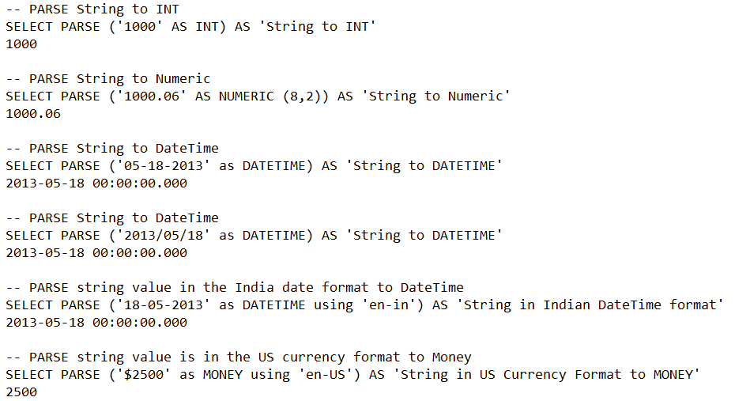

**TRY_CAST:** Returns a value cast to the specified data type if the cast succeeds; otherwise, returns null. Instead of returning an error message it returns null. However, if you request a conversion that is explicitly not permitted, then fails with an error.

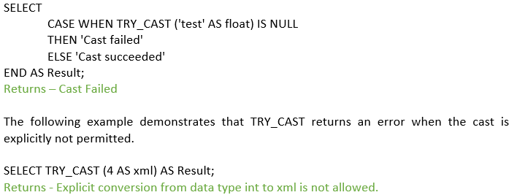

**TRY_CONVERT:** Returns a value cast to the specified data type if the cast succeeds; otherwise, returns null. However, if you request a conversion that is explicitly not permitted, then fails with an error.

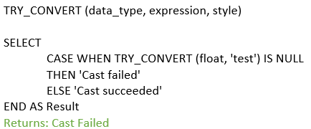

**TRY_PARSE:** Returns the result of an expression, translated to the requested data type, or null if the cast fails. However, if you request a conversion that is explicitly not permitted, then fails with an error.

TRY_PARSE (string_value AS data_type [ USING culture])

**string_value:** nvarchar (4000) value representing the formatted value to parse into the specified data type.

**data_type:** Literal representing the data type requested for the result.

**culture:** Optional string that identifies the culture in which string_value is formatted.

SELECT TRY_PARSE ('Jabberwokkie' AS datetime2 USING 'en-US') AS Result;

Returns - NULL

## CURSOR FUNCTIONS

**@@CURSOR_ROWS:** This returns the number of qualifying rows currently in the last cursor opened on the connection.

**-1:** The cursor is dynamic. Because dynamic cursors reflect all changes, the number of rows that qualify for the cursor constantly changes. The cursor does not necessarily retrieve all qualified rows.

**0:** No cursors have been opened, no rows qualified for the last opened cursor, or the last-opened cursor is closed or deallocated.

**n:** The cursor is fully populated. The value returned (n) is the total number of rows in the cursor

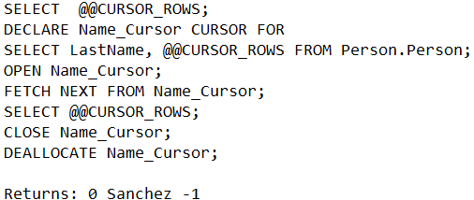

**@@FETCH_STATUS**: Returns the status of the last cursor FETCH statement issued against any cursor currently opened by the connection.

**0:** The FETCH statement was successful.

**-1:** The FETCH statement failed or the row was beyond the result set.

**-2:** The row fetched is missing.

**-9:** The cursor is not performing a fetch operation.

The following example uses @@FETCH_STATUS to control cursor activities in a WHILE loop.

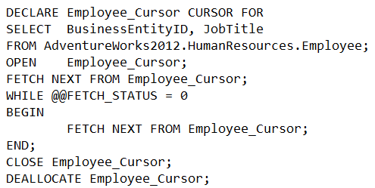

**CURSOR_STATUS:** shows whether or not a cursor declaration has returned a cursor and result set.

**1:** The cursor result set has at least one row.

**0:** The cursor result set is empty.

**-1:** The cursor is closed.

**-2:** The previously called procedure did not assign a cursor to this OUTPUT variable or No cursor is assigned to the declared cursor variable or the previously assigned procedure assigned a cursor to this OUTPUT variable, but the cursor was in a closed state when the procedure completed. Therefore, the cursor is deallocated, and not returned to the calling procedure.

**-3:** A cursor with specified name does not exist.

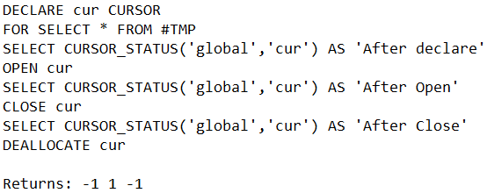

## DATE & TIME FUNCTIONS

**@@DATEFIRST:** DATEFIRST specifies/ returns the first day of the week.

If language is set to Italian then

SELECT @@DATEFIRST

1 (which is MONDAY)

If language is set to Italian then

SELECT @@DATEFIRST

7 (I.E. SUNDAY)

**CURRENT_TIMESTAMP:** This function returns the current database system timestamp as a **datetime value.**

SELECT CURRENT_TIMESTAMP

RETUNS - 2007-04-30 13:10:02.047

**DATEADD:** This function adds a specified number value (as a signed integer) to a specified *datepart* of an input *date* value, and then returns that modified value.

DATEADD (datepart, number, date)

DATE part can be Year, quarter, month, day, week, hour, minutes, seconds etc.

In below example DATEADD returns the last day of the return month. For example, September has 30 (thirty) days therefore for both the select queries it returns 2006-09-30 00:00:00.000 as results.

SELECT DATEADD (month, 1, '20060830');

SELECT DATEADD (month, 1, '20060831');

DECLARE @datetime2 datetime2 = '2007-01-01 13:10:10.1111111';

SELECT 'year', DATEADD (year,1, @datetime2)

Year 2008-01-01 13:10:10.1111111

SELECT 'quarter', DATEADD (quarter, 1, @datetime2)

quarter 2007-04-01 13:10:10.1111111

SELECT 'month', DATEADD (month, 1, @datetime2)

month 2007-02-01 13:10:10.1111111

SELECT 'dayofyear', DATEADD (dayofyear, 1, @datetime2)

dayofyear 2007-01-02 13:10:10.1111111

SELECT 'day', DATEADD (day,1, @datetime2)

day 2007-01-02 13:10:10.1111111

SELECT 'week', DATEADD (week, 1, @datetime2)

week 2007-01-08 13:10:10.1111111

SELECT 'weekday', DATEADD (weekday, 1, @datetime2)

weekday 2007-01-02 13:10:10.1111111

SELECT 'hour', DATEADD (hour, 1, @datetime2)

hour 2007-01-01 14:10:10.1111111

SELECT 'minute', DATEADD (minute, 1, @datetime2)

Minute 2007-01-01 13:11:10.1111111

SELECT 'second', DATEADD (second, 1, @datetime2)

second 2007-01-01 13:10:11.1111111

SELECT 'millisecond', DATEADD (millisecond, 1, @datetime2)

millisecond 2007-01-01 13:10:10.1121111

SELECT 'microsecond', DATEADD (microsecond, 1, @datetime2)

microsecond 2007-01-01 13:10:10.1111121

SELECT 'nanosecond', DATEADD (nanosecond, 1, @datetime2);

nanosecond 2007-01-01 13:10:10.1111111

**DATEDIFF:** This function returns the count (as a signed integer value) of the specified datepart boundaries crossed between the specified startdate and enddate.

DATEDIFF (datepart, startdate, enddate)

SELECT DATEDIFF (year, '2005-12-31 23:59:59', '2006-01-01 00:00:00')

RETUNS 1

SELECT DATEDIFF (quarter, '2005-12-31 23:59:59', '2006-01-01 00:00:00')

RETUNS 1

SELECT DATEDIFF (month, '2005-12-31 23:59:59', '2006-01-01 00:00:00')

RETUNS 1

SELECT DATEDIFF (dayofyear, '2005-12-31 23:59:59', '2006-01-01 00:00:00')

RETUNS 1

SELECT DATEDIFF (day, '2005-12-31 23:59:59', '2006-01-01 00:00:00')

RETUNS 1

SELECT DATEDIFF (week, '2005-12-31 23:59:59', '2006-01-01 00:00:00')

RETUNS 0

SELECT DATEDIFF (hour, '2005-12-31 23:59:59', '2006-01-01 00:00:00')

RETUNS 1

SELECT DATEDIFF (minute, '2005-12-31 23:59:59', '2006-01-01 00:00:00')

RETUNS 1

SELECT DATEDIFF (second, '2005-12-31 23:59:59', '2006-01-01 00:00:00')

RETUNS 1

**DATEFROMPARTS:** Returns a **date** value for the specified year, month, and day.

DATEFROMPARTS (year, month, day)

SELECT DATEFROMPARTS (2010, 12, 31) AS Result;

Returns - 2010-12-31

**DATENAME:** Returns a character string that represents the specified *datepart* of the specified *date*

DATENAME (datepart, date)

If the data type of the date argument does not have the specified datepart, the default for that datepart will be returned only when a literal is specified for date.

For example, the default year-month-day for any date data type is 1900-01-01. The following statement has date part arguments for datepart, a time argument for date, and returns 1900, January, 1, 1, Monday.

SELECT DATENAME (year, '12:10:30.123')

Returns 1900

SELECT DATENAME (month, '12:10:30.123')

January

SELECT DATENAME (day, '12:10:30.123')

1

SELECT DATENAME (weekday, '12:10:30.123')

MONDAY

If date is specified as a variable or table column and the data type for that variable or column does not have the specified datepart, error 9810 is returned. The following code example fails because the date part year is not a valid for the time data type that is declared for the variable @t.

DECLARE @t time = '12:10:30.123'

SELECT DATENAME (year, @t)

Returns ERROR

**DATEPART:** Returns an integer that represents the specified *datepart* of the specified *date*.

DATEPART (datepart, date)

SELECT DATEPART (YEAR, '08-06-2018')

Returns 2018

SELECT DATEPART (MONTH, '00:00:01.1234567')

Returns 06

SELECT DATEPART (DAY, '00:00:01.1234567')

Returns 08

SELECT DATEPART (WEEKDAY, '00:00:01.1234567')

Returns 05

**DAY:** Returns an integer representing the day (day of the month) of the specified date.

SELECT DAY ('2015-04-30 01:01:01.1234567')

RETURNS 30

SELECT YEAR (0), MONTH (0), DAY (0);

RETURNS 1900, 1, 1

**EOMONTH:** Returns the last day of the month that contains the specified date, with an optional offset.

DECLARE @date DATETIME = '12/1/2011';

SELECT EOMONTH (@date) AS Result;

RETURNS 2011-12-31

DECLARE @date DATETIME = GETDATE ()

SELECT EOMONTH (@date) AS 'This Month'

This Month 2011-12-31

SELECT EOMONTH (@date, 1) AS 'Next Month'

Next Month 2012-01-31

SELECT EOMONTH (@date, -1) AS 'Last Month'

Last Month 2011-11-30

**GETDATE:** Returns the current database system timestamp as a **datetime** value without the database time zone offset. This value is derived from the operating system of the computer on which the instance of SQL Server is running.

SELECT GETDATE ()

RETURNS 2007-04-30 13:10:02.047

**GETUTCDATE:** Returns Coordinated Universal time

SELECT GETUTCDATE ()

RETURNS 2007-05-30 01:16:14.003

**ISDATE:** Returns 1 if the *expression* is a valid **date**, **time**, or **datetime** value; otherwise, 0.

ISDATE returns 0 if the *expression* is a **datetime2** value.

SET LANGUAGE us_english;

SET DATEFORMAT mdy;

SELECT ISDATE ('04/15/2008'); Returns 1

SELECT ISDATE ('04-15-2008'); Returns 1

SELECT ISDATE ('04.15.2008'); Returns 1

SELECT ISDATE ('04/2008/15'); Returns 1

SET DATEFORMAT mdy;

SELECT ISDATE ('15/04/2008'); Returns 0

SELECT ISDATE ('15/2008/04'); Returns 0

SELECT ISDATE ('2008/15/04'); Returns 0

SELECT ISDATE ('2008/04/15'); Returns 1

SET DATEFORMAT dmy;

SELECT ISDATE ('15/04/2008'); Returns 1

SELECT ISDATE ('15/2008/04'); Returns 1

SELECT ISDATE ('2008/15/04'); Returns 1

SELECT ISDATE ('2008/04/15'); Returns 1

SET LANGUAGE English;

SELECT ISDATE ('15/04/2008'); Returns 0

SET LANGUAGE Hungarian;

SELECT ISDATE ('15/2008/04'); Returns 0

SET LANGUAGE Swedish;

SELECT ISDATE ('2008/15/04'); Returns 0

SET LANGUAGE Italian;

SELECT ISDATE ('2008/04/15'); Returns 1

**MONTH:** Returns an integer that represents the month of the specified date.

SELECT MONTH ('2007-04-30'); Returns 04

**YEAR:** Returns an integer that represents the month of the specified date.

SELECT YEAR ('2007-04-30'); Returns 2007

## MATHEMATICAL FUNCTIONS

**ABS:** A mathematical function that returns the absolute (positive) value of the specified numeric expression. ABS change negative values to positive values. ABS has no effect on zero or positive values.

SELECT ABS (-1.0), ABS (0.0), ABS (1.0);

Returns: 1.0 .0 1 .0

**CELING:** This function returns the smallest integer greater than, or equal to, the specified numeric expression

SELECT CEILING ($123.45), CEILING ($-123.45), CEILING ($0.0);

Returns: 124.00 -123.00 0.00

**EXP:** Returns the exponential value of the specified **float** expression.

The constant e (2.718281…), is the base of natural logarithms. The exponent of a number is the constant e raised to the power of the number. For example,

EXP (1.0) = e^1.0 = 2.71828182845905 and EXP (10) = e^10 = 22026.4657948067.

DECLARE @var float

SET @var = 10

SELECT 'The EXP of the variable is: ' + CONVERT (varchar, EXP(@var))

The EXP of the variable is: 22026.5

**FLOOR:** Returns the largest integer less than or equal to the specified numeric expression.

SELECT FLOOR (123.45), FLOOR (-123.45), FLOOR ($123.45)

Result: 123.00 -124.00 123.00

**POWER:** Returns the value of the specified expression to the specified power.

SELECT POWER (2, 3) RETURNS 8

SELECT POWER (2.5, 3) RETUNS 15.625

**RAND:** Returns a pseudo-random **float** value from 0 through 1, exclusive.

SELECT RAND ();

Return a random decimal number between 0 and 1:

SELECT RAND (6);

Return a random decimal number (with seed value of 6):

SELECT RAND () * (10-5) + 5;

Return a random decimal number >= 5 and <10:

SELECT FLOOR (RAND () * (10-5+1) + 5);

Return a random number >= 5 and <=10:

**ROUND:** Returns a numeric value, rounded to the specified length or precision.

Positive number rounds on the right side of the decimal point. Negative number rounds on the left side of the decimal point. Truncation of the value to round occurs when this value is not 0 or not included

ROUND (numeric_expression, length, [function])

SELECT ROUND (444, 1) 444 - No rounding with no digits right of the decimal point

SELECT ROUND (444, -1) 440 - Rounding down

SELECT ROUND (444, 2) 444 - No rounding with no digits right of the decimal point

SELECT ROUND (444, -2) 400 - Rounding down

SELECT ROUND (444, 3) 444 - No rounding with no digits right of the decimal point

SELECT ROUND (444, -3) 0 - Insufficient number of digits

SELECT ROUND (444, 4) 444 - No rounding with no digits right of the decimal point

SELECT ROUND (444, -4) 0- Insufficient number of digits

SELECT ROUND (555, 1) 555 - No rounding with no digits right of the decimal point

SELECT ROUND (555, -1) 560 - Rounding up

SELECT ROUND (555, 2) 555 - No rounding with no digits right of the decimal point

SELECT ROUND (555, -2) 600 - Rounding up

SELECT ROUND (555, 3) 555 - No rounding with no digits right of the decimal point

SELECT ROUND (555, -3) 1000 - Rounding up

SELECT ROUND (555, 4) 555 - No rounding with no digits right of the decimal point

SELECT ROUND (555, -4) 0 - Insufficient number of digits

**SQRT:** Returns the square root of the specified float value.

SELECT SQRT (4);

Returns: 2

**SQUARE:** Returns the square of the specified float value.

SELECT SQUARE (2)

Returns: 4

## LOGICAL FUNCTIONS

**IIF:** Returns one of two values, depending on whether the Boolean expression evaluates to true or false in SQL Server.

IIF (boolean_expression, true_value, false_value)

DECLARE @A int = 45, @B int = 40;

SELECT IIF (@A > @B, 'TRUE', 'FALSE') AS Result;

Returns: TRUE

**CHOOSE:** Returns the item at the specified index from a list of values in SQL Server.

CHOOSE (index, val_1, val_2 [, val_n])

SELECT CHOOSE (3, 'Manager', 'Director', 'Developer', 'Tester') AS Result;

Returns: Developer

## RANKING FUNCTION

**RANK:** The ranking window function returns a unique rank number for each distinct row within the partition according to a specified column value, starting at 1 for the first row in each partition, with the same rank for duplicate values and leaving gaps between the ranks.

Without partition by:

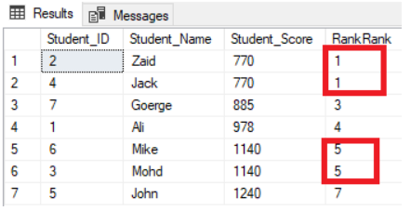

With Partition by:

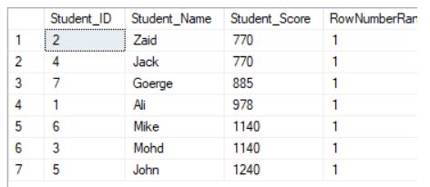

**DENSE_RANK:** This function returns the rank of each row within a result set partition, with no gaps in the ranking values. The rank of a specific row is one plus the number of distinct rank values that come before that specific row.

DENSE_RANK () OVER (partition_by_clause order_by_clause)

Without partition by:

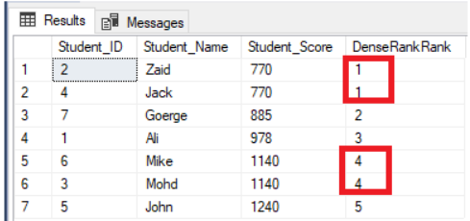

With partition by:

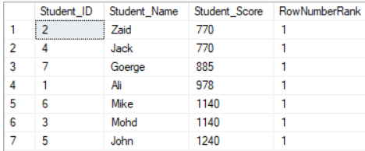

**ROW_NUMBER:** Numbers the output of a result set. More specifically, returns the sequential number of a row within a partition of a result set, starting at 1 for the first row in each partition.

Without partition by:

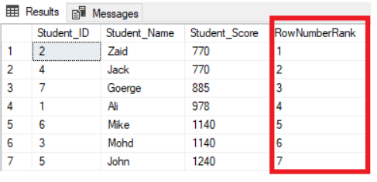

With partition by:

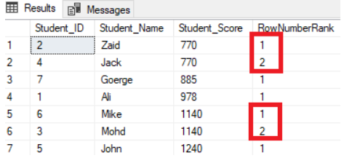

**NTILE:** Distributes the rows in an ordered partition into a specified number of groups. The groups are numbered, starting at one. For each row, NTILE returns the number of the group to which the row belongs.

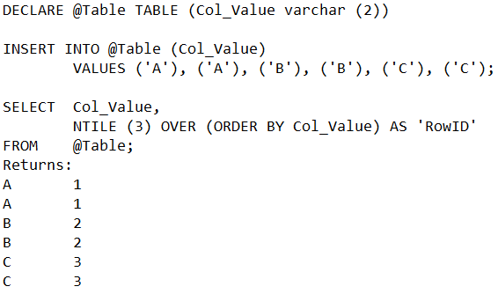

## STRING FUNCTIONS

**ASCII:** Returns the ASCII code value of the leftmost character of a character expression.

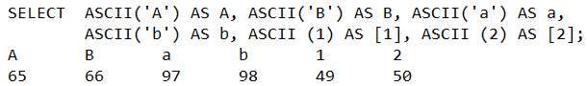

**CHAR:** This function converts an **int** ASCII code to a character value

SELECT CHAR (78)

RETUNS (N)

**CHARINDEX:** This function searches for one-character expression inside a second character expression, returning the starting position of the first expression if found.



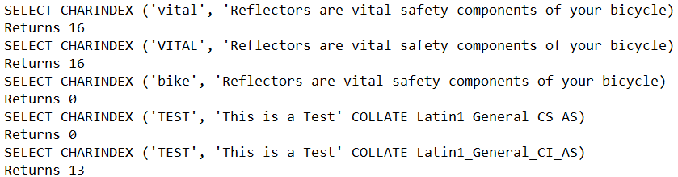

**CONCAT:** This function returns a string resulting from the concatenation, or joining, of two or more string values in an end-to-end manner.



SELECT CONCAT ('Happy ', 'Birthday ', 11, '/', '25') AS Result;

Happy Birthday 11/25

**CONCAT_WS:** This function returns a string resulting from the concatenation, or joining, of two or more string values in an end-to-end manner. It separates those concatenated string values with the delimiter specified in the first function argument.

SELECT CONCAT_WS (‘-’, 'Happy ', 'Birthday) AS Result;

Happy-Birthday

**FORMAT:** Returns a value formatted with the specified format and optional culture in SQL Server 2017. Use the FORMAT function for locale-aware formatting of date/time and number values as strings. For general data type conversions, use CAST or CONVERT.

FORMAT (value, format, culture)

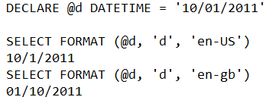

**LEFT:** Returns the left part of a character string with the specified number of characters.



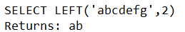

**LEN:** Returns the number of characters of the specified string expression, excluding trailing blanks. LEN excludes trailing blanks. If that is a problem, consider using the [DATALENGTH](https://docs.microsoft.com/en-us/sql/t-sql/functions/datalength-transact-sql?view=sql-server-2017) function which does not trim the string.

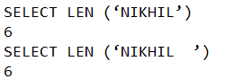

**LOWER:** Returns a character expression after converting uppercase character data to lowercase.

**LTRIM:** Returns a character expression after it removes leading blanks.

**PATINDEX:** Returns the starting position of the first occurrence of a pattern in a specified expression, or zeros if the pattern is not found, on all valid text and character data types.

PATINDEX ('%pattern%', expression)



**QUOTENAME:** Returns a Unicode string with the delimiters added to make the input string a valid SQL Server delimited identifier.



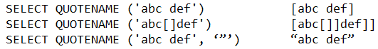

**REPLACE:** Replaces all occurrences of a specified string value with another string value.



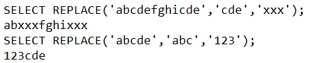

**REPLICATE:** Repeats a string value a specified number of times.



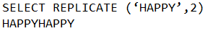

**REVERSE:** Returns the reverse order of a string value.

**RIGHT:** Returns the right part of a character string with the specified number of characters.



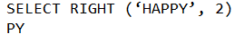

**RTRIM:** Returns a character string after truncating all trailing spaces.

**SPACE:** Returns a string of repeated spaces.

SELECT ‘Nikhil’ + SPACE (1) + ‘Guleria’

Nikhil Guleria

**STR:** Returns character data converted from numeric data.



**float_expression:** Is an expression of approximate numeric (**float**) data type with a decimal point.

***Length*:** Is the total length. This includes decimal point, sign, digits, and spaces. The default is 10.

***Decimal*:** Is the number of places to the right of the decimal point. *decimal* must be less than or equal to 16. If *decimal* is more than 16 then the result is truncated to sixteen places to the right of the decimal point.

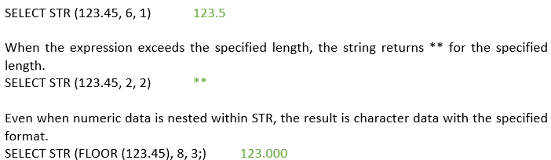

**STUFF:** The STUFF function inserts a string into another string. It deletes a specified length of characters in the first string at the start position and then inserts the second string into the first string at the start position.

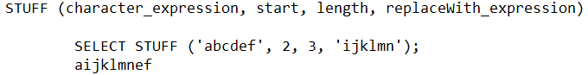

**SUBSTRING:** Returns part of a character, binary, text, or image expression in SQL Server.

SUBSTRING (expression, start, length)

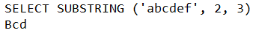

**TRIM:** Removes the space character char (32) or other specified characters from the start or end of a string.

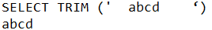

**UPPER:** Returns a character expression after converting lowercase character data to uppercase.

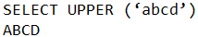

# STORED PROCEDURE

A stored procedure is a group of one or more Transact-SQL statements that are used to perform a specific task.

* We can pass zero or many parameters to SP.
* We can return one to many or zero result via SP.
* We can use temp tables inside SP.
* We can use transactions inside SP.
* We can perform error handling inside SP.
* We can call view or function inside SP.
* We can prevent SQL injections via SP.
* We can perform data manipulation via SP.
* Contain programming statements that perform operations in the database. These include calling other procedures.
* Return a status value to a calling program to indicate success or failure (and the reason for failure).

Input parameters allow the caller to pass a data value to the stored procedure.

Output parameters allow the stored procedure to pass a data value or a cursor variable back to the caller. User-defined functions cannot specify output parameters.

Every stored procedure returns an integer return code to the caller. If the stored procedure does not explicitly set a value for the return code, the return code is 0. A negative number is returned for failure.

## BENEFITS OF SP

**Reduced server/client network traffic:** The commands in a procedure are executed as a single batch of code. This can significantly reduce network traffic between the server and client because only the call to execute the procedure is sent across the network. Without the code encapsulation provided by a procedure, every individual line of code would have to cross the network.

**Stronger security:** Multiple users and client programs can perform operations on underlying database objects through a procedure, even if the users and programs do not have direct permissions on those underlying objects. The procedure controls what processes and activities are performed and protects the underlying database objects. This eliminates the requirement to grant permissions at the individual object level and simplifies the security layers.

**SQL injection:** Using procedure parameters helps guard against SQL injection attacks. Since parameter input is treated as a literal value and not as executable code, it is more difficult for an attacker to insert a command into the Transact-SQL statement(s) inside the procedure and compromise security.

**Reuse of code:** You can create the procedure once, store it in the database, and call it any number of times in your program.

**Improved performance:** If the operation requires a large amount of SQL code that is performed repetitively, stored procedures can be faster. They are parsed and optimized when they are first executed, and a compiled version of the stored procedure remains in a memory cache for later use. This means the stored procedure does not need to be reparsed and reoptimized with each use, resulting in much faster execution times.

## TYPES OF STORED PROCEDURES

**User-defined:** A user-defined procedure can be created in a user-defined database or in all system databases except the **Resource** database.

**Temporary:** Temporary procedures are a form of user-defined procedures. The temporary procedures are like a permanent procedure, except temporary procedures are stored in **tempdb**. There are two types of temporary procedures: local and global. They differ from each other in their names, their visibility, and their availability. Local temporary procedures have a single number sign (#) as the first character of their names; they are visible only to the current user connection, and they are deleted when the connection is closed. Global temporary procedures have two number signs (##) as the first two characters of their names; they are visible to any user after they are created, and they are deleted at the end of the last session using the procedure.

**System:** System procedures are included with SQL Server. They are physically stored in the internal, hidden **Resource** database and logically appear in the **sys** schema of every system- and user-defined database. In addition, the **msdb** database also contains system stored procedures in the **dbo** schema that are used for scheduling alerts and jobs. Because system procedures start with the prefix **sp_**, we recommend that you do not use this prefix when naming user-defined procedures.

**Extended User-Defined:** Extended procedures enable creating external routines in a programming language such as C. These procedures are in DLLs that an instance of SQL Server can dynamically load and run.

Extended SP routines residing in DLLs that function similarly to regular stored **procedures**. They receive parameters and return results via **SQL Server's** Open Data Services API and are usually written in C or C++. They must reside in the master database and run within the **SQL Server** process space.

## STORED PROCEDURE SYNTAX

A Stored Procedure can be created using below syntax:

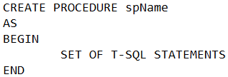

Blow syntax is an example of SP with input parameter:

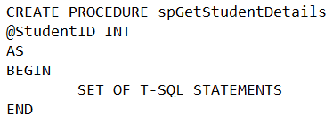

Blow syntax is an example of SP with input & output parameters:

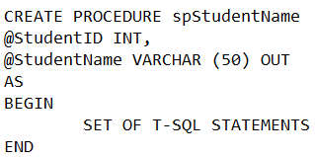

The output can be fetched using below syntax:

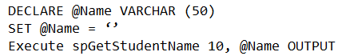

Below syntax shows an example of SP with input & output parameters and returns the return code as well:

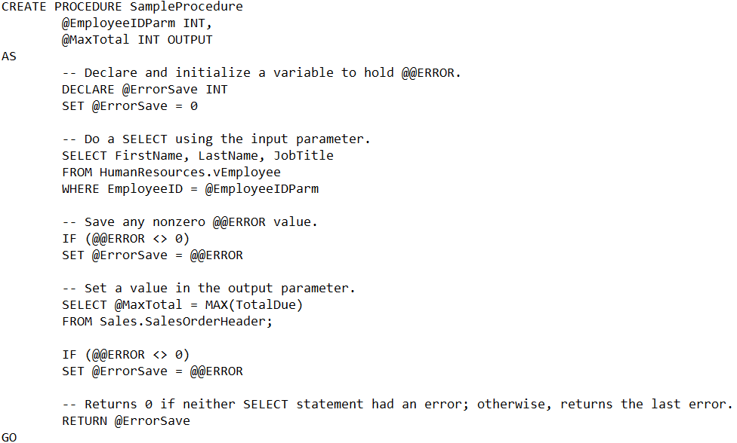

Above SP can be execute using below code:

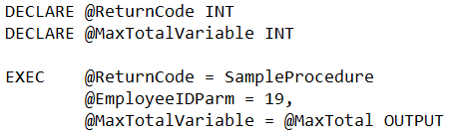

# TRIGGERS

Triggers are special type of stored procedure basically associated with a table that are automatically fired/executed when a certain event (inset, update or delete) occurs in the database. Hence, we can say that Triggers are event driven database objects.

The only way to test a trigger is by firing the trigger that is by firing the transaction will enable the trigger.

If the trigger fails then the associated transaction will be rolled back and it will be lost, hence at most care should be taken while writing code for the trigger.

Triggers are usually used to preserve data integrity, to control server operations, to audit a server and to implement business logic or business rule.

We can write commit and rollback within a trigger code but its not advisable as implicit transaction will be started by SQL server which will server the purpose.

## DDL TRIGGERS

DDL Triggers are executed when a DDL Statements like CREATE, ALTER, DROP, GRANT, DENY, REVOKE, and UPDATE STATISTICS statements are executed. Certain system stored procedures that perform DDL like operations can also fire DDL triggers. DDL triggers can be DATABASE scoped or SERVER scoped.

Use DDL triggers when you want to do the following:

* Prevent certain changes to your database schema.
* Have something occur in the database in response to a change in your database schema.
* Record changes or events in the database schema.

Magic tables ‘INSERTED’ AND ‘DELETED’ are not created for DDL triggers

The DDL triggers with Server level scope gets fired in response to a DDL statement with server scope like CREATE DATABASE, CREATE LOGIN, GRANT_SERVER, ALTER DATABASE, ALTER LOGIN etc. Whereas DATABASE scoped DDL triggers fire in response to DDL statement with DATABASE SCOPE like CREATE TABLE, CREATE PROCEDURE, CREATE FUNCTION, ALTER TABLE, ALTER PROCEDURE, ALTER FUNCTION etc.

Below shows a syntax example:

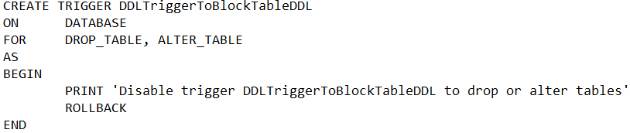

## DML TRIGGERS

DML triggers are executed when a DML operation like INSERT, UPDATE OR DELETE is fired on a Table or View. DML Triggers are of the following two types:

**AFTER Triggers**: AFTER Triggers are executed after the DML statement completes but before it is committed to the database. AFTER Triggers if required can rollback it’s actions and source DML statement which invoked it.

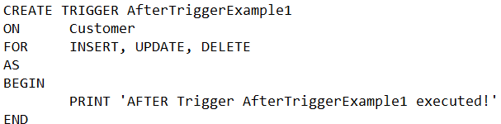

**INSTEAD OF Triggers:** INSTEAD OF Triggers are the triggers which gets executed automatically in place of triggering DML (i.e. INSERT, UPDATE and DELETE) action. It means if we are inserting a record and we have an INSTEAD OF trigger for INSERT then instead of INSERT whatever action is defined in the trigger that gets executed.

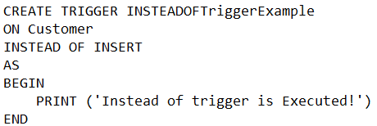

DML Triggers have access to the two special logical Tables named INSERTED and DELETED, these are the temporary tables which Sql Server manages. These tables structure will be same as that of the table on which the DML action is fired and holds the old and new values of the rows which are modified by the DML statement.

DELETED logical table will hold the rows which are deleted from the trigger table (i.e. the table on which the trigger is defined) by the DELETE or UPDATE operation. An UPDATE DML operation is internally executed as first the deletion of the existing record and then insertion of the new record.

INSERTED logical table will hold the rows which are inserted by the INSERT and UPDATE statement.

## LOGON TRIGGERS

Logon Triggers gets executed automatically in response to a LOGON event. They get executed only after the successful authentication but before the user session is established. If authentication fails the logon triggers will not be fired.

## CLR TRIGGERS

CLR Triggers are based on the Sql CLR. We can write DML and DDL triggers by using the Supported .NET CLR languages like C#, VB.NET etc. CLR triggers will useful if require heavy computation in the trigger or require reference to object outside SQL.

## MAGIC TABLES

Within triggers we have two virtual tables:

* Inserted and deleted tables.
* Both tables are maintained in tempdb.

Inserted table will give access to rows that are coming in. Inserted table will have values if INSERT or UPDATE is performed. It will be created when DELETE is performed but table will not contain any data.

Deleted table will give access to rows being deleted and being updated. Will have values for DELETE and UPDATE but not for INSERT.

# TRANSACTIONS

A transaction is a single unit of work. Transactions group a set of tasks into a single execution unit. Each transaction begins with a specific task and ends when all the tasks in the group successfully complete. If any of the tasks fail, the transaction fails. Therefore, a transaction has only two results: success or failure.

A database transaction, by definition, must be atomic, consistent, isolated and durable. These are popularly known as ACID properties.

* **Atomicity** requires that a transaction that involves two or more discrete parts of information must commit all parts or none.
* **Consistency** requires that a transaction must create a valid state of new data, or it must roll back all data to the state that existed before the transaction was executed.
* **Isolation** requires that a transaction that is still running and did not commit all data yet, must stay isolated from all other transactions.
* **Durability** requires that committed data must be stored using method that will preserve all data in correct state and available to a user, even in case of a failure.

## TYPES OF TRANSACTIONS

SQL Server operates in the following transaction modes:

**Autocommit Transactions:** Each individual statement is a transaction.

**Explicit transactions:** Each transaction is explicitly started with the BEGIN TRANSACTION statement and explicitly ended with a COMMIT or ROLLBACK statement.

**Implicit transactions:** A new transaction is implicitly started when the prior transaction completes, but each transaction is explicitly completed with a COMMIT or ROLLBACK statement.

## WHEN TO USE TRANSACTIONS

* In batch processing, where multiple rows must be inserted, updated, or deleted as a single unit
* Whenever a change to one table requires that other tables be kept consistent
* When modifying data in two or more databases concurrently
* In distributed transactions, where data is manipulated in databases on various servers

## TYPES OF LOCKS

When a transaction occurs in a database it imposes a lock on an object. All other transactions that require the access to that object will be forced to wait until the lock is released and that wait will be registered with the adequate wait type.

Lock mode considers various lock types that can be applied to a resource that has to be locked:

* Shared
* Update
* Exclusive
* Intent
* Schema
* Bulk update
* Key - Range

**SHARED LOCKS:** These locks are acquired by readers during read operations such as SELECT. I’d like to mention that it happens in most part of the cases but not all the time. There are some cases when readers don’t acquire (S) locks. We will talk about it later.

**EXCLUSIVE LOCKS:** These locks acquired by writers during data modification operators such as Insert, Update or Delete. Those locks prevent one object to be modified by the different sessions. Those locks are always acquired and held till end of transaction

**UPDATE LOCKS:** These locks are the mix between shared and exclusive locks. SQL Server uses them with data modification statements while searching for the rows need to be modified. For example, if you issue the statement like: “update MyTable set Column1 = 0 where Column1 is null” SQL Server acquires update lock for every row it processes while searching for Column1 is null. When eligible row found, SQL Server converts (U) lock to (X).

**INTENT LOCKS:** Intent locks are a means in which a transaction notifies other transaction that it is intending to lock the data. Their purpose is to assure proper data modification by preventing other transactions to acquire a lock on the object higher in lock hierarchy. This prevents other transactions from putting exclusive locks on the table that would try to cancel the row/page lock. For example, if row has (X) lock, it would introduce (IX) locks on page, table and database level.

**SCHEMA LOCKS:** used when an operation dependent on the schema of the table is executed.

**BULK UPDATE LOCKS:** used while doing bulk copy to a table. TABLOCK hint is specified.

**KEY RANGE LOCKS:** protects the range of rows read by a query using serializable transaction isolation level.

## ISOLATION LEVELS

Controls the locking and row versioning behaviour of T-SQL statements.

**READ UNCOMMITTED:** Query within current transaction can read rows that have been modified by other transactions but not yet committed.

* No shared locks are requested to prevent other transactions from modifying data read by the current transaction.
* READ UNCOMMITTED transactions are also not blocked by exclusive locks that would prevent the current transaction from reading rows that have been modified but not committed by other transactions.
* Results in dirty read, non-repeatable read and phantom read.
* This option has the same effect as setting NOLOCK on all tables in all SELECT statements in a transaction.
* This is the least restrictive of the isolation levels.

**READ COMMITTED:** Specifies that statements cannot read data that has been modified but not committed by other transactions.

* This prevents dirty reads.
* Data can be changed by other transactions hence resulting in non-repeatable read and phantom read.
* This option is the SQL Server default.

**REPEATABLE READ:** Specifies that statements cannot read data that has been modified but not yet committed by other transactions and that no other transactions can modify data that has been read by the current transaction until the current transaction completes.

* Shared locks are placed on all data read by each statement in the transaction and are held until the transaction completes.
* This prevents other transactions from modifying any rows that have been read by the current transaction.
* No dirty read and non – repeatable read but phantom read can occur.

**SERIALIZABLE:** Specifies the following

* Statements cannot read data that has been modified but not yet committed by other transactions. Hence no dirty read.
* No other transactions can modify data that has been read by the current transaction until the current transaction completes. Hence no non – repeatable read.
* Other transactions cannot insert new rows with key values that would fall in the range of keys read by any statements in the current transaction until the current transaction completes. Hence no phantom read.

Range locks are placed in the range of key values that match the search conditions of each statement executed in a transaction. This blocks other transactions from updating or inserting any rows that would qualify for any of the statements executed by the current transaction. This means that if any of the statements in a transaction are executed a second time, they will read the same set of rows. The range locks are held until the transaction completes. This is the most restrictive of the isolation levels because it locks entire ranges of keys and holds the locks until the transaction completes.

**SNAPSHOT:** Specifies that data read by any statement in a transaction will be the transactionally consistent version of the data that existed at the start of the transaction.

The transaction can only recognize data modifications that were committed before the start of the transaction. Data modifications made by other transactions after the start of the current transaction are not visible to statements executing in the current transaction.

## DIRTY READ

Session 1 begins a transaction and modifies data. Session 2 reads the modified data before Session 1 commits the transaction. Session 2 is reading data that exists only in theory because the Session 1 transaction might be rolled back. If that occurs, the data read by Session 2 is no longer valid.

## NONREPEATABLE READ

Session 1 begins a transaction and retrieves a row of data from a table. Session 2 updates that row. Session 1 tries to retrieve the row once more, still within the original transaction, but receives different results because of the Session 2 update.

## PHANTOM READ

Session 1 begins a transaction and retrieves several rows of data from a table. Session 2 inserts a row into the same table, and the insert coincides with the search criteria of the Session 1 statement. When Session 1 reruns the query, the new row added by Session 2 is now included in the results.

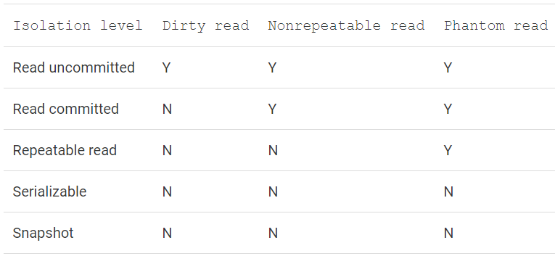

# QUERY PERFORMANCE

When a query is submitted for execution, query execution process goes through below steps:

1. Parsing
2. Resolving
3. Optimization

## EXECUTION PLAN

Execution plans can tell you how a query will be executed, or how a query was executed.

We can use the execution plan to identify the exact piece of SQL code that is causing the problem. For example, it may be scanning an entire table-worth of data when, with the proper index, it could simply backpack out only the rows you need. All this and more is displayed in the execution plan.

## WHAT HAPPENS WHEN A QUERY IS SUBMITTED?

When we submit a query to a SQL Server database, a number of processes on the server go to work on that query.

These processes are run for each and every query submitted to the system. While there are lots of different actions occurring simultaneously within SQL Server, we’re going to focus on the processes around T-SQL. They break down roughly into two stages:

* Processes that occur in the relational engine.

In the relational engine the query is parsed and then processed by the Query Optimizer, which generates an execution plan.

* Processes that occur in the storage engine.

The plan is sent (in a binary format) to the storage engine, which it then uses to retrieve or update the underlying data. The storage engine is where processes such as locking, index maintenance and transactions occur. Execution plans are created in the relational engine.

## QUERY PARSING

When you pass a T-SQL query to the SQL Server system, the first place it goes to is the relational engine.

As the T-SQL arrives, it passes through a process that checks that the T-SQL is written correctly, that it’s well formed. This process is known as query parsing. The output of the Parser process is a parse tree, or query tree (or even sequence tree). The parse tree represents the logical steps necessary to execute the query that has been requested.

If the T-SQL string is not a data manipulation language (DML) statement, it will be not be optimized because, for example, there is only one “right way” for the SQL Server system to create a table; therefore, there are no opportunities for improving the performance of that type of statement.

If the T-SQL string is a DML statement, the parse tree is passed to a process called the algebrizer. The algebrizer resolves all the names of the various objects, tables and columns, referred to within the query string. The algebrizer identifies, at the individual column level, all the types of the objects being accessed. It also determines the location of aggregates (such as GROUP BY, and MAX) within the query, a process called aggregate binding.

This algebrizer process is important because the query may have aliases or synonyms, names that don’t exist in the database, that need to be resolved, or the query may refer to objects not in the database.

The algebrizer outputs a binary called the query processor tree, which is then passed on to the query optimizer.

## THE QUERY OPTIMIZER

Using the query processor tree and the statistics it has about the data, it works out what it thinks will be the optimal way to execute the query – that is, it generates an execution plan.

The decisions made by the optimizer are based on what it calculates to be the cost of a given execution plan, in terms of the required CPU processing and I/O, and how fast it will execute. Hence, this is known as a cost-based plan.

The optimizer will generate and evaluate many plans (unless there is already a cached plan) and will choose the lowest-cost plan i.e. the plan it thinks will execute the query as fast as possible and use the least amount of resources, CPU and I/O. Sometimes, the optimizer will select a less efficient plan if it thinks it will take more time to evaluate many plans than to run a less efficient plan.

If you submit a very simple query – for example, a single table with no indexes and with no aggregates or calculations within the query – then rather than spend time trying to calculate the absolute optimal plan, the optimizer will simply apply a single, trivial plan to these types of queries.

If the query is non-trivial (not small or complex), the optimizer will perform a cost-based calculation to select a plan. In order to do this, it relies on statistics that are maintained by SQL Server.

Statistics are collected on columns and indexes within the database, and describe the data distribution and the uniqueness, or selectivity of the data. The information that makes up statistics is represented by a histogram, a tabulation of counts of the occurrence of a particular value, taken from 200 data points evenly distributed across the data. It’s this “data about the data” that provides the information necessary for the optimizer to make its calculations.

If statistics exist for a relevant column or index, then the optimizer will use them in its calculations. Statistics, by default, are created and updated automatically within the system for all indexes or for any column used as a predicate, as part of a WHERE clause or JOIN ON clause.

Table variables do not ever have statistics generated on them, so they are always assumed by the optimizer to have a single row, regardless of their actual size. Temporary tables do have statistics generated on them and are stored in the same histogram as permanent tables, for use within the optimizer.

The optimizer takes these statistics, along with the query processor tree and heuristically determines the best plan.

Once the optimizer arrives at an estimated execution plan, the actual plan is created and stored in a memory space known as the plan cache – unless an identical plan already exists in the cache.

As the optimizer generates potential plans, it compares them to previously generated plans in the cache. If it finds a match, it will use that plan.

Query Execution

Once the execution plan is generated, the action switches to the storage engine, where the query is actually executed, according to the plan.

## QUERY EXECUTION

Once the execution plan is generated, the action switches to the storage engine, where the query is actually executed, according to the estimated plan. This is where the actual execution plan is generated.

## ESTIMATED AND ACTUAL EXECUTION PLANS

There are two distinct types of execution plan. First, there is the plan that represents the output from the optimizer. This is known as an Estimated execution plan. The operators, or steps, within the plan will be labeled as logical, because they’re representative of the optimizer’s view of the plan.

Next is the plan that represents the output from the actual query execution. This type of plan is known, funnily enough, as the Actual execution plan. It shows what actually happened when the query executed.

## EXECUTION PLAN REUSE

It is expensive for the Server to generate execution plans so SQL Server will keep and reuse plans wherever possible. As they are created, plans are stored in a section of memory called the plan cache).

When a query is submitted to the server, an estimated execution plan is created by the optimizer. Once that plan is created, and before it gets passed to the storage engine, the optimizer compares this estimated plan to actual execution plans that already exist in the plan cache. If an actual plan is found that matches the estimated one, then the optimizer will reuse the existing plan, since it’s already been used before by the query engine.

Execution plans are not kept in memory forever. They are slowly aged out of the system using an “age” formula that multiplies the estimated cost of the plan by the number of times it has been used (e.g. a plan with a cost of 10 that has been referenced 5 times has an “age” value f of 50).

If the following criteria are met, the plan is removed from memory:

* More memory is required by the system
* The “age” of the plan has reached zero
* The plan isn’t currently being referenced by an existing connection

The following actions can lead to recompilation of an execution plan:

* Changing the structure or schema of a table referenced by the query
* Changing an index used by the query
* Dropping an index used by the query
* Updating the statistics used by the query
* Calling the function, sp_recompile
* Subjecting the keys in tables referenced by the query to a large number of inserts or deletes
* For tables with triggers, significant growth of the inserted or deleted tables
* Mixing DDL and DML within a single query, often called a deferred compile

## WHY THE ACTUAL AND ESTIMATED EXECUTION PLANS MIGHT DIFFER

Generally, we won’t see any differences between your estimated and actual execution plans. However, circumstances can arise that can cause differences between the estimated and actual execution plans.

* When Statistics are Stale
* When the Estimated Plan is Invalid
* When Parallelism is Requested

**WHEN STATISTICS ARE STALE:** The main cause of a difference between the plans is differences between the statistics and the actual data. This generally occurs over time as data is added and deleted. This causes the key values that define the index to change, or their distribution (how many of what type) to change. The automatic update of statistics that occurs, assuming it’s turned on, only samples a subset of the data in order to reduce the cost of the operation. This means that, over time, the statistics become a less-and-less accurate reflection of the actual data. Not only can this cause differences between the plans, but you can get bad execution plans because the statistical data is not up to date.

**WHEN THE ESTIMATED PLAN IS INVALID:** The optimizer, which is what is used to generate Estimated Execution plans, doesn’t execute T-SQL. It does run the statements through the algebrizer, the process outlined earlier that is responsible for verifying the names of database objects. Since the query has not yet been executed, the temporary table does not yet exist. This is the cause of the error. Running this same bit of code through the Actual execution plan will work perfectly fine.

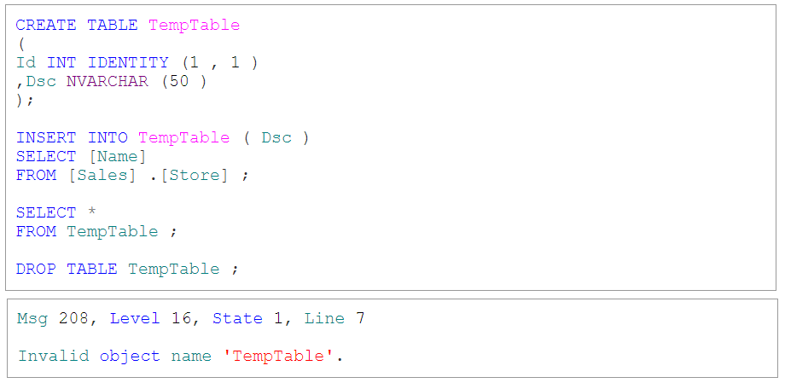

**WHEN PARALLELISM IS REQUESTED:** When a plan meets the threshold for parallelism (more about this in Chapter 8) two plans are created. Which plan is actually executed is up to the query engine. So you might see a plan with, or without, parallel operators in the estimated execution plan. When the query actually executes, you may see a completely different plan if the query engine determines that it either can’t support a parallel query at that time or that a parallel query is called for.

# CONTROL FLOW

The Transact-SQL control-of-flow language keywords are:

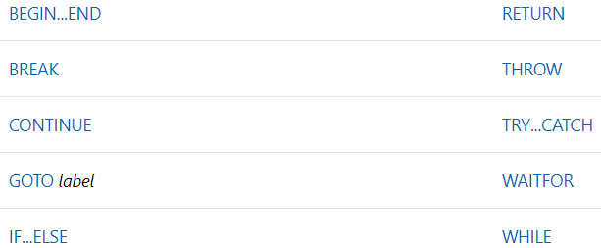

# REFERENCES

Query optimization:

<https://www.red-gate.com/simple-talk/sql/performance/execution-plan-basics/>

Column store index

<https://docs.microsoft.com/en-us/sql/relational-databases/indexes/columnstore-indexes-overview?view=sql-server-2017>